DermaVision


By:

Ali Akbar
11250

Salman Ahmed
13296

Ch Muhammad Haseeb
11608

Supervised by:
Syed Murtaza Pasha

Faculty of Computing
Riphah International University, Islamabad
Fall 2022
A Dissertation Submitted To

Faculty of Computing,
Riphah International University, Islamabad
As a Partial Fulfillment of the Requirement for the Award of the Degree of
Bachelors of Science in Software Engineering

Faculty of Computing
Riphah International University, Islamabad

Date: [08-02-2023]
Final Approval

This is to certify that we have read the report submitted by Ali Akbar (11250), Salman Ahmed (13296), Ch Muhammad Haseeb (11608) for the partial fulfillment of the requirements for the degree of the Bachelors of Science in Software Engineering (BSSE). It is our judgment that this report is of sufficient standard to warrant its acceptance by Riphah International University, Islamabad for the degree of Bachelors of Science in Software Engineering (BSSE).

Committee:

1 | Syed Murtaza Pasha  (Supervisor)
2 | Dr. Muhammad Zubair  (Head of Department/Chairman)

Declaration

We hereby declare that this document “Derma Vision” neither as a whole nor as a part has been copied out from any source. It is further declared that we have done this project with the accompanied report entirely on the basis of our personal efforts, under the proficient guidance of our teachers especially our supervisor Syed Murtaza Pasha. If any part of the system is proved to be copied out from any source or found to be reproduction of any project from anywhere else, we shall stand by the consequences.

___________________________
Ali Akbar
11250

___________________________
Salman Ahmed
13296

___________________________
Ch Muhammad Haseeb
11608

Dedication
We dedicate our work to our teachers, family, and friends. The peerless encouragement from our teachers and prayers from our parents is what leads to the success of our final year project. We dedicate our work to our supervisor Syed Murtaza Pasha and the respected faculty members.
Acknowledgement

First of all, we are obliged to Allah Almighty the Merciful, the Beneficent, and the source of all Knowledge, for granting us the courage and knowledge to complete this Project.
We are grateful to our respected supervisor Syed Murtaza Pasha, we are highly obliged for his considerations, the suggestions he gave us to make our project a masterpiece. Also, a special thanks to the rest of the faculty members for their unconditional support. We are thankful to our parents for the love and encouragement they provided us with throughout the project.

___________________________
Ali Akbar
11250

___________________________
Salman Ahmed
13296

___________________________
Ch Muhammad Haseeb
11608

Abstract

This report documents the development of the system “Derma Vision”, an android application that uses artificial intelligence to detect various skin diseases. The person will not require to go for medical checkup but through real time image processing he/she will able to get the skin disease detection results either by uploading images of the skin or using camera just by sitting at home After Diagnosis of Skin Disease, the system will be able to diagnose major skin diseases and provide their result with describing the details of diagnosed condition.
Our system also suggest medication if the disease is non-contagious otherwise the facility for nearest available doctor for checkup and pharmacy for medicine will be given.
DermaVision helps to resolve many of the issues and digitized the system i.e., to overcome the problems of patients going to hospital.
Table of Contents

Chapter 1: Introduction | 12
- Opportunity & Stakeholders | 13
1.1.1 Opportunity | 13
1.1.2 Stakeholder | 14
- Motivations and Challenges | 14
- Goals and Objectives | 15
- Solution Overview | 15
- Report Outline | 16
Chapter 2: Literature / Market Survey | 17
2.1 Introduction | 18
2.2 Literature Review/Technologies Overview | 18
2.3 Market Survey Table | 19
2.4 Summary | 21
Chapter 3: Requirement Engineering | 22
3.1 Introduction | 23
3.2 Problem Scenarios | 23
3.2.1 Patient Problem | 23
3.2.2 Doctor Problem | 24
3.3 Requirements | 24
3.3.1 Requirement Elicitation Techniques | 24
3.3.1.1 Existing Systems | 24
3.3.1.2 Brainstorming | 24
3.3.1.3 Interviews | 24
3.3.1.4 Wireframing | 25
3.3.2 Functional Requirements | 25
3.3.2.1 FR01: Admin | 25
3.3.2.2 FR02: System | 27
3.3.2.3 FR03: User | 27
Chapter 4: System Design | 29
4.1 Introduction | 30
4.2 Architectural Design | 30
4.3 Detailed Diagram | 31
4.3.1 Class Diagram | 32
4.3.2 Use Case Diagram | 33
4.3.3 Use Case Fully Dressed Format | 34
Use Case-01 Admin Login | 34
Use Case-02 Admin Signup | 35
Use Case-03 Admin Forgot Password | 36
Use Case-04 User Login | 37
Use Case-05 User Signup | 38
Use Case-06 User Forgot Password | 39
Use Case-07 User Open Camera | 41
Use Case-08 User Search Pharmacy | 42
Use Case-09 User View Pharmacy | 42
Use Case-10 User Search Doctor | 43
Use Case-11 User View Doctor | 45
Use Case-12 User Make Complaint | 46
Use Case-13 Get Disease Information | 47
Use Case-14 View Result | 48
Use Case-15 Delete Result | 49
Use Case-16 Add Patient Details | 50
Use Case-17 Update Patient Details | 51
Use Case-18 View Complaint | 52
Use Case-19 Update Complaint | 53
Use Case-20 Delete Complaint | 54
Use Case-21 Add Pharmacy | 54
Use Case-22 Delete Pharmacy | 55
Use Case-23 Update Pharmacy | 56
Use Case-24 Add Doctor | 57
Use Case-25 Update Doctor | 57
Use Case-26 Delete Doctor | 58
Use Case-27 View Patient Details User | 59
Use Case-28 Delete Patient Details User | 60
Use Case-29 View Patient Details Admin | 61
Use Case-30 Delete Patient Details Admin | 61
Use Case-31 Logout User | 63
Use Case-32 Logout Admin | 64
4.3.4 Activity Diagram | 64
4.3.4.1 Admin Signup | 65
4.3.4.2 Admin Login | 66
4.3.4.3 Admin Forgot Password | 67
4.3.4.4 User Signup | 68
4.3.4.5 User Login | 69
4.3.4.6 User Forgot Password | 70
4.3.4.7 User Take Image | 71
4.3.4.8 User Search Pharmacy | 72
4.3.4.9 User View Pharmacy | 73
4.3.4.10 User View Doctor | 74
4.3.4.11 User Search Doctor | 75
4.3.4.12 User Make Complaint | 76
4.3.4.13 User Get Diagnostic Information | 77
4.3.4.14 User View Result | 78
4.3.4.15 User Delete Result | 79
4.3.4.16 User Add Patient Details | 80
4.3.4.17 User Update Patient Details | 81
4.3.4.18 User View Patient Details | 82
4.3.4.19 User Delete Patient Details | 83
4.3.4.20 User Take Survey | 84
4.3.4.21 View Complaint | 85
4.3.4.22 Update Complaint | 86
4.3.4.23 Delete Complaint | 87
4.3.4.24 Add Pharmacy | 88
4.3.4.25 Delete Pharmacy | 89
4.3.4.26 Update Pharmacy | 90
4.3.4.27 Admin View Patient Details | 91
4.3.4.28 Admin Delete Patient Details | 92
4.3.4.29 Admin Add Doctor | 93
4.3.4.30 Admin View Doctor | 94
4.3.4.31 Admin Delete Doctor | 95
4.3.4.34 Logout Admin | 96
4.3.4.35 Logout User | 97
4.3.5 Sequence Diagram | 98
4.3.6 Data Model Diagram | 131
Chapter 5: Implementation | 132
5.1 Endeavour | 133
5.2 Component, Libraries, Web Services and Stub | 133
5.3 IDE, Tools and Technologies | 134
5.4 Database | 134
5.5 Work | 134
5.6 Best Practices / Coding Standards | 136
5.7 Deployment Environment | 137
5.8 Summary | 138
Chapter 6: Testing and Evaluation | 139
6.1 Introduction | 140
6.2 List of Test Scenarios | 140
6.3 Performance and Evaluation | 156
6.4 Summary | 165
Chapter 7: Conclusion and Outlook | 166
7.1 Introduction | 167
7.2 Achievements and Improvements | 167
7.3 Critical Review | 167
7.4 Future Recommendations/Outlook | 168
7.5 Summary | 168
References
Appendices
Appendix-A: Software Requirements Specifications (SRS)
Appendix-B: Design Documents
Appendix-C: Coding Standards/Conventions
Appendix-D: Test Scenarios
Appendix-E: Work Breakdown Structure
Appendix-F: Roles & Responsibility Matrix

List of Figures

1.1 Caption of first figure of first chapter | 6
1.2 Caption of second figure of first chapter | 7
2.1 Caption of first figure of second chapter | 14
2.2 Caption of second figure of second chapter | 22
2.3 Caption of third figure of second chapter | 26
5.1 Caption of first figure of fifth chapter | 49
5.2 Caption of second figure of fifth chapter | 49

List of Tables

1.1 label of first table of first chapter | 6
1.2 label of second table of first chapter | 7
2.1 label of first table of second chapter | 14
2.2 label of second table of second chapter | 22
2.3 label of third table of second chapter | 26
5.1 label of first table of fifth chapter | 49
5.2 label of second table of fifth chapter | 49

Chapter 1: Introduction

Chapter 1:
Introduction

Derma Vision is an android mobile software solution that provides a platform for detecting diseases related to skin. This application basically works on artificial intelligence and image processing technology through which any user can detect skin condition either through camera or image scanning. This application not only provides user with the option of scanning through image processing but questionnaire-based system is also added for the user who don’t want to upload any of the disease images. In this chapter we will be exploring our project idea in depth and then analyze the idea from various viewpoints. We will talk about the opportunity, that we see in this project idea and what are the needs of involved stakeholders that we are focusing on. After that, we will discuss the motivational factors involved with this project and discuss some of the challenges that likely to face while implementing this project. Rest of this chapter will then focus on the goals and objectives of our project. Lastly, a proposed solution and outline of the report content will be explained.

  - Opportunity and Stakeholders

    - Opportunity

Skin diseases are more common than other diseases. Skin diseases can be caused by fungal infection, bacteria, allergies or viruses, etc. Advances in lasers and photonics-based medical technologies have made it much faster and more accurate to diagnose skin diseases. But the cost of such a diagnosis is still limited and very expensive. Most of the time patient don’t opt for checkup or booking an appointment for dermatologist/skin specialist in order to get their skin checked. They usually ignore it. They either don’t want to pay too much fee or sometimes too lazy to go for routine checkup. But they ignore the fact that this disease can cause life threatening consequences if left untreated. There exists an opportunity to make something that can help the patients from the hustle of booking appointment or going for a regular checkup even if some patterns suddenly show up on their skin. Thus, image processing techniques help to build an automated screening system for dermatology at an early stage. Feature extraction plays a key role in skin disease classification. Computer vision plays a role in the detection of skin diseases in various techniques. Moreover, the chances of early detection of melanoma (skin cancer) can be detected and diagnosed with the help of Artificial Intelligence where it can be treated at an early stage.

    - Stakeholders

- User
- Doctor
- Pharmacist
- Admin

  - Motivation and Challenges

In this segment, we will be discussing the inspirations and motivations that is associated with the project idea that will bring a useful impact in the lives of millions of people who suffer from skin diseases on a daily basis but cannot afford to pay expensive fees of doctors. We have also written down the challenges that this project may bring when deployed in real market environments. As the task of handling data of unlimited user will not be as easy as it seems. On the other hand, the motivation is far greater than the challenges because with the help of this application many lives can be saved and creating the awareness among the people who suffer from harsh skin conditions can be cured when diagnosed at an early stage. There may be challenges that we can face with our application is with the precision and accuracy of our algorithm which can detect the skin disease correctly. Moreover, many of the user may or may not be ready to upload pictures of private parts of their bodies where the condition exists. In fear of getting their data stolen or misused. Lastly, the suggestion of prescription may cause some side effects to patients who are allergic to certain chemical compounds and formulas.

  - Goals and Objectives

The goal of this project is to provide a platform for the user who can detect skin disease at home without going for a physical inspection. A platform that can help save lives of thousands of patients who suffer for chronic skin diseases through detection at an early stage. Regardless of affordability constraints this application will help detection of skin diseases of every patient who has the application installed on their mobile devices. As we know that skin cancer is considered to be one of the deadliest forms of melanoma, Early stages of detection can save a life with the chance of 100 percent success rate. Moreover, User can have one platform for getting their disease diagnosis and getting information for different doctors who can treat their disease. Option for Nearby Pharmacy will also be provided where the pharmacist will also be helped as they will be getting more customers. This way stakeholders like doctor and pharmacists will be getting benefit from the application as its open doors for more customers.

  - Solution Overview

Our Project is based on Mobile Application that will use Artificial Intelligence to detect various skin diseases. Our proposed solution will not require customer to go for a medical checkup but through real-time image processing, he/she will be able to get the skin disease diagnostics results either by uploading images of the skin or taking photos just by sitting at home After Diagnosis of Skin Disease, our system will define the percentage match, characteristics, threat and risk of disease. Completing the previous process our System will also propose available Treatment and medications if the disease is non-contagious and can be treated at home with the precaution for the people with allergic reactions. Otherwise, the option for Doctor’s availability will also be provided to the user.

1.5 Report outline

In the further chapters, this report will cover the literature review and market surveys where the detailed analysis of currently available solutions will be made and we will try to establish ground that DermaVision is better than existing solutions in the market in many ways. After that, we will discuss the functional and non-functional requirements of the proposed solution in detail. Then we will shift towards system design where various technical diagrams and artifacts would be discussed. The implementation chapter will cover all the issues related to the implementation of this project. After the implementation section, we will focus on the testing of this solution. In that section, our focal point is mainly black box testing where the functionality of the system would be tested according to its specification to make sure it is error-free. In the last chapters, we will conclude all the discussion and try to draw some results out of that.

Chapter 2:
Literature / Market Survey

Chapter 2:
Literature / Market Survey

2.1 Introduction

Our Project is based on Detection of Major Skin Diseases that are found in humans. We plan to develop a fully functional Mobile Application that will detect certain skin diseases through Artificial Intelligence and Image Processing. Our Project will cover and include major study of dermatology in order to make the detection results as efficient as possible. Our application will allow user to capture the image of affected area of skin disease and them by certain algorithms and analysis the application will detect the disease. Additionally, our system will then provide different recommendations of prescriptions, Nearby Dermatologists, Pharmacy and Hospitals. Skin disease detection app with all the appropriate needs is such a crucial task in which we fulfill all aspects. There are several systems that provide individual services in their system. In this chapter, we will analyze all the available systems in the market that claim to provide skin disease detection and services, platform to customer / patients, and try to draw out their deficiencies and weaknesses. After that, we will compare our proposed solution to the available systems in the market and see how our proposed solution is filling all the gaps and shortcomings that are present in the currently available solutions. We have used the internet to study different systems and used our case study.

2.2 Literature Review

There are many existing systems all over the world that work on skin disease detection and most of them have an objective to grow their business without the perception of what the user demands. There are many systems in the market that claim that they provide a platform for skin disease detection but no platform where other facilities and services can come along to facilitate the user with less time, cost and more features.

2.3 Market Survey Table

System | Features
 | Category | Intended Users | Image Processing | Free
SkiniveMD | Mobile Application | Dermatologists | ✓ | ✓
First Derm | Hybrid | Patients | ✓ | ✕
Triage | Web  Application | Everyone | ✓ | ✕
Skin Vision | Mobile Application | Dermatologists | ✕ | ✕
Table 1.1(a): Market Review
System | Features
 | Sign-In | Manage Patient | Available Doctors | Locate Nearest Pharmacist
SkiniveMD | ✓ | ✓ | ✕ | ✕
First Derm | ✕ | ✓ | ✓ | ✕
Triage | ✓ | ✕ | ✓ | ✕
Skin Vision | ✓ | ✓ | ✓ | ✕
Table 1.1(b): Market Review

System | Features
 | Category | Intended Users | Image Processing | Free
Skin Sight | Web Application | Patients | ✓ | ✕
AI Derm | Hybrid | Patients | ✓ | ✓
DermaVision | Mobile Application | Patients and Dermatologists | ✓ | ✓
Table 1.2(a): Market Review

System | Features
 | Sign-In | Manage Patient | Available Doctors | Locate Nearest Pharmacist
Skin Sight | ✓ | ✓ | ✕ | ✕
AI Derm | ✕ | ✓ | ✓ | ✕
DermaVision | ✓ | ✓ | ✓ | ✓
Table 1.2(b): Market Review

SkiniveMD - A
First Derm - B
Triage - C
Skin Vision - D
Skin Sight - E
AI Derm – F
Derma Vision - G
2.4 Summary

After deeply studying and analyzing these above systems, we found out that the success of the system depends on fulfilling the need and demand of the user. As the user is considered a top priority and so the success of a such systems depend on the user requirements. As these applications don't provide certain necessary features such as Nearby pharmacy & consultation with available doctor these services are required when you have a system based on medical app. By providing these features the customer satisfaction will help in the success of our system which will consequently urge more people to use our application.

Chapter 3:
Requirement Analysis

Chapter 3:
Requirement Analysis

3.1 Introduction

In this chapter, we will discuss all the functional and non-functional requirements of skin disease detection. Prior to that, we will discuss all the problem statements that we have found while researching the project idea. Skin disease detection withholds Fifty-five functional requirements. These requirements are gathered through various requirement gathering techniques involving Brainstorming, Interviewing, and Observing. The non-functional requirements are drawn by observing the gathered requirements and type of our system.

3.2 Problem scenarios
There are many problem scenarios considering the point of view for doctors and patients. In which both faces problem in their own forms. But we are going to be targeting the most crucial ones that will be most affected in the presence or absence of the application.
Following are all of the identified problems:

3.2.1. Patient problem
Elements | Descriptions
The problem of | Patients often ignore some skin moles, patterns or cysts on our body and don't go for a checkup. that can turn out to be a skin disease which is harming our body.
Affects | Patients.
The result of which | Patient usually start their treatment when the disease is almost entirely spread.  Which can be fatal.
Benefits of | 1: Patient able to detect Skin Disease through their mobile devices and asses what type of skin disease they are encountered with.  2: Patient will know the Risk of the disease and what can be the consequences of it, if left untreated.

3.2.2. Doctor problem
Elements | Descriptions
The problem of | Doctor often gets confused in diagnosing the skin condition as diseases evolve over time by changing different shapes and colors. As Skin Cancer has complex structure and uncountable forms which is not easily detectable.
Affects | Patients, Doctors.
The result of which | Can be fatal for human life.
Benefits of | Doctors been able to double check through our application will be beneficial for both doctors and patients.

3.3 Requirement
3.3.1 Requirement Elicitation Techniques:
Different Requirement Elicitation Techniques were used in order to gather and review different opinions of customers. This has helped us produce a clear straight path in developing an application that is going to be helpful to majority of customer demand.

3.3.1.1 Existing systems
We reviewed existing systems to study what kind of features they offer and how much they are useful for patients. Some of the systems provide essential features but some were not properly addressed. Many gaps were identified which led us to create an app that is going to be made according to the demand of customer.

      - Brainstorming
Helped us in bringing possible features to reality after reading and analyzing different systems and through constant research on increasing the efficiency of the system and how we can integrate an algorithm that provides accurate results.

      - Interviews
Our vital source for gathering requirements, we met different Dermatologists from our city and inquired about different problems they face. They helped us in understanding the whole process of different skin diseases and their medication and process of treatment.

3.3.1.4 Wire Framing
We have developed a wire frame that helped us in clarifying requirements and bought us all to one page over workflow. We were able to predict visual interface through complete system wire frames. The technology we used for designing wire frames is figma.
SEE APPENDEX B

3.3.2 Functional Requirements:

Below is the table for all of the Functional Requirements our system will implement. There are the requirements that must be fulfilled to accomplish our end product. Writing them in simple form like below will help us both stakeholders and development tram in understanding the working of the system.

3.3.2.1 FR-01: Admin
ID | Requirement | Comment
FR-01.1 | Admin shall be able to sign up for his/her account | Admin will sign up his/her account by typing in name, username, email and password.
FR-01.2 | Admin shall be able to login his/her account | Admin will login his/her account by typing in username and password
FR-01.3 | Admin shall be able to update his/her profile | Admin will update his/her profile.
FR-01.4 | Admin shall be able to use forgot password. | Admin will use forgot password if he/she forgets password.
FR-01.5 | Admin shall be able to view users | All the registered users will be seen by admin.
FR-01.6 | Admin shall be able to delete users | Admin will have the authority to delete users.
FR-01.7 | Admin shall be able to view user results | Admin will have the authority to view results of patients
FR-01.8 | Admin shall be able to view total detected diseases | Admin will have the authority to view how many diseases have been detected.
FR-01.9 | Admin shall be able to view all the pharmacies. | Admin will have the authority to view all the pharmacies.
FR-01.10 | Admin shall be able to view all the doctors. | Admin will have the authority to view all the doctors.
FR-01.11 | Admin shall be able to add pharmacy details | Admin will have the authority to add details of nearest available pharmacy in the area.
FR-01.12 | Admin shall be able to delete pharmacy details. | Admin will have the authority to delete pharmacy.
FR-01.13 | Admin shall be able to add dermatologist details. | Admin will have the authority to add details of dermatologist.
FR-01.14 | Admin shall be able to delete dermatologist’s details. | Admin will have the authority to delete dermatologists details.
FR-01.15 | Admin shall be able to view the complaints. | Admin will view the complaints by the users.
FR-01.16 | Admin shall be able to block users. | Admin will block users permanently in case of complaints against them.
FR-01.17 | Admin shall be able to notify users. | Admin will notify users in case if necessary.
FR-01.18 | Admin shall be able to logout | Admin will logout from his/her account.

3.3.2.2 FR-02: System
ID | Requirement | Comment
FR-02.1 | System shall be able to provide result of the disease. | System will show result by providing disease match.
FR-02.2 | System shall be able to show accuracy of the disease | System will provide output for percentage match.
FR-02.3 | System shall be able to provide risk level of the disease | System will provide Risk of the disease from low to high.

3.3.2.3 FR-03: User
ID | Requirement | Comment
FR-03.1 | User shall be able to sign up for his/her account. | User will sign up his/her account by providing name, email and password.
FR-03.2 | User shall be able to login his/her account | After registration the User will login by entering email and password.
FR-03.3 | User shall be able to update his/her profile | User will edit his/her profile.
FR-03.4 | User shall be able to use forgot password. | User will use forgot password if he/she forgets password.
FR-03.5 | User shall be able to search for available doctors | User will search for available doctors in the area.
FR-03.6 | User shall be able to locate nearest pharmacy | User will use location to find nearest pharmacy in his area.
FR-03.7 | User shall detect disease by selecting photo from gallery | User can select photo from gallery.
Fr-03.8 | User shall detect disease by taking photo from camera | User can take photos to detect disease.
FR-03.9 | User shall be able to view results. | User will have the authority to view results
FR-03.10 | User shall be able to add patient test | User will have the authority to add test of patient
FR-03.11 | User shall be able to delete patient test | User will have the authority to delete test of patient
FR-03.12 | User shall be able to search patient by name | User will have the authority search patient by name.
FR-03.13 | User shall be able to search patient by Id | User will have the authority search patient by Id.
FR-03.14 | User shall be able to detect through questionnaire | User can detect disease through questionnaire.
FR-03.15 | User shall be able to upload his/her profile picture. | User will have the authority to upload his profile picture.
FR-03.16 | User shall be able to change his/her password | User will have the authority to change his password by entering his old password and then new one.
FR-03.17 | User Shall be able to logout | User will logout from his/her account.
FR-03.18 | User shall be able to delete account. | User can delete his/her account.

Chapter 4:
System Design

Chapter 4:
System Design

System Design
  - Introduction

In this chapter we will elaborate detail System designs starting from the very first Architectural design and then followed by Use cases. We will illustrate “Use case diagrams” as well as detailed use case textual details in fully dress format. After that, we will discuss system “Sequence Diagrams” and “Class diagram”. In all the diagrams, we will try to draw out the workflow and technical design of System. All the responsibilities, attributes, operations and relationships of components of the software and determines how a component should be adopted to conform to the implementation environment will be properly defined.
4.2 Architecture Diagram
- Data layer: This layer is the one in charge of interacting with APIs.
- Domain layer: This is the one in charge of transforming the data that comes from the data layer.
And finally, we want to manage the state of that data and present it on our user interface, that’s why we split the presentation layer in two:
- Business logic layer: This layer manages the state (usually using flutter bloc).
- Presentation layer: Renders UI components based on state.

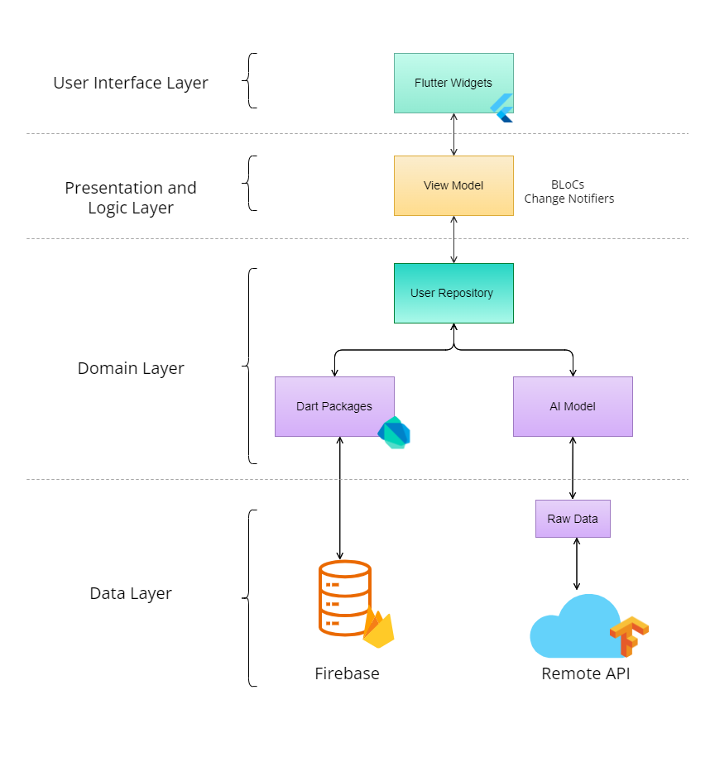

Bloc: The BLoC pattern is reactive and decouples the UI logic from the business logic for it to be developed independently. BLoC stands for Business Logic Components; it aims to separate the application's business logic from User Interface, making the application code more unambiguous, scalable, and testable.

  - Detailed Diagram
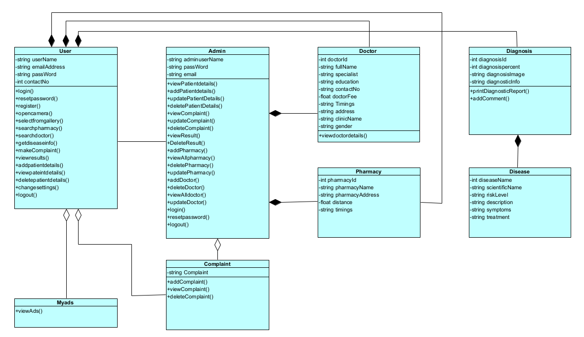
4.3.1 Class Diagram

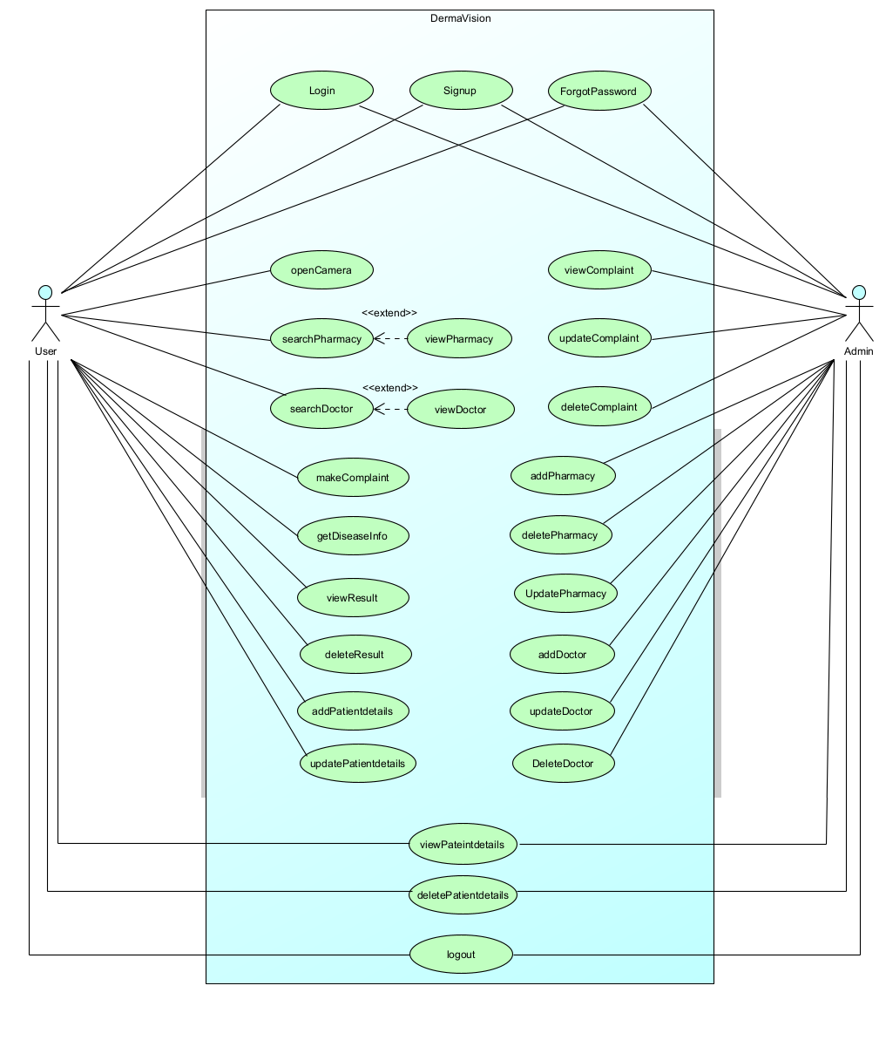
4.3.2 Use Case Diagram

4.3.3 Use Case Fully Dress Format

Use Case-01 Admin Login
Use Case Name | Admin Login
Use case ID | UC-01
Level | User Level
Primary Actor | Admin
Stakeholders And Interests | Admin will login for his/her account to further continue the use of system.
Precondition | Admin will provide all the required information in login form.
Post condition | Admin get himself/herself logged in with the system.
Main Success Scenario
  Action | Response
  This use case initiates by the  Admin when he/she wants to login on system.  1. Admin clicks on login button in admin panel.  3. Admin enters mandatory information such as email, and password.  5. Admin press the “Login” button. | 2. System displays login form.  4. System checks the formats and credentials entered by admin.  6. System successfully logs in the admin,
Alternative Scenario | 1a. Invalid Credentials:  - The system displays an error message.  - Re-enter the credentials.  - Click on Login button.  - Admin successfully logged in the system.  1b. Empty Fields:  - The system displays an error message.  - Admin will fill the empty field.  - Admin click on Login button.  - Admin successfully registered in the system.
Technical Requirements | Admin must have a device capable to run browser and internet connection.

Use Case-02 Admin Signup
Use Case Name | Admin Signup
Use case ID | UC-02
Level | User Level
Primary Actor | Admin
Stakeholders And Interests | Admin will sign-up for his/her account to get registered into the system.
Precondition | Admin will provide all the required information in signup form.
Post condition | Admin get himself/herself signed up with the system.
Main Success Scenario
  Action | Response
  This use case initiates by the  Admin when he/she wants to sign-up on the system.  1. Admin clicks on signup button in admin panel.  3. Admin enters mandatory information such as username, email, and password.  5. Admin press the “Signup” button. | 2. System displays signup form.  4. System checks the formats and credentials entered by admin.  6. System successfully get registered using signup.
Alternative Scenario | 1a. Invalid Credentials:  - The system displays an error message.  - Re-enter the credentials.  - Click on Signup button.  - Admin successfully signs up in the system.  1b. Empty Fields:  - The system displays an error message.  - Admin will fill the empty field.  - Admin click on Signup button.  - Admin successfully registered in the system.
Technical Requirements | Admin must have a device capable to run browser and internet connection.

Use Case-03 Admin Forgot Password
Use Case Name | Admin Forgot Password
Use case ID | UC-03
Level | User Level
Primary Actor | Admin
Stakeholders And Interests | Admin will be able to change password if he/she forgot the login credentials.
Precondition | Admin will provide all the required information to process the reset password request.
Post condition | Admin will be able to change the password successfully.
Main Success Scenario
  Action | Response
  This use case initiates by the  Admin when he/she forgot the password of the system.  1. Admin clicks on forgot password button in admin panel.  3. Admin enters mandatory information such as email of the registered account.  5. Admin press the “Reset Password” button. | 2. System displays forgot password form.  4. System checks the formats and credentials entered by admin.  6. System will send an email with OTP code to the user’s respective email address where he/she will enter new password.
Alternative Scenario | 1a. Invalid Credentials:  - The system displays an error message.  - Re-enter the credentials.  - Click on Reset Password button.  - Admin successfully change the password in the system.  1b. Empty Fields:  - The system displays an error message.  - Admin will fill the empty field.  - Admin click on Reset Password button.  - Admin successfully reset the password in the system.
Technical Requirements | Admin must have a device capable to run browser and internet connection.

Use Case-04 User Login
Use Case Name | User Login
Use case ID | UC-04
Level | User Level
Primary Actor | User
Stakeholders And Interests | User will login for his/her account to further continue the use of system.
Precondition | User will provide all the required information in login form.
Post condition | User get himself/herself logged in with the system.
Main Success Scenario
  Action | Response
  This use case initiates by the  User when he/she wants to login on system.  1. User clicks on login button in admin panel.  3. User enters mandatory information such as email, and password.  5. User press the “Login” button. | 2. System displays login form.  4. System checks the formats and credentials entered by user.  6. System successfully logs in the user,
Alternative Scenario | 1a. Invalid Credentials:  - The system displays an error message.  - Re-enter the credentials.  - Click on Login button.  - User successfully logged in the system.  1b. Empty Fields:  - The system displays an error message.  - User will fill the empty field.  - User click on Login button.  - User successfully registered in the system.
Technical Requirements | User must have Android mobile device capable to run Android version 12 or more and stable internet connection.

Use Case-05 User Signup
Use Case Name | User Signup
Use case ID | UC-05
Level | User Level
Primary Actor | User
Stakeholders And Interests | User will sign-up for his/her account to get registered into the system.
Precondition | User will provide all the required information in signup form.
Post condition | User get himself/herself signed up with the system.
Main Success Scenario
  Action | Response
  This use case initiates by the  User when he/she wants to sign-up on the system.  1. User clicks on signup button in User panel.  3. User enters mandatory information such as username, email, and password.  5. User press the “Signup” button. | 2. System displays signup form.  4. System checks the formats and credentials entered by User.  6. System successfully get registered using signup.
Alternative Scenario | 1a. Invalid Credentials:  - The system displays an error message.  - Re-enter the credentials.  - Click on Signup button.  - User successfully signs up in the system.  1b. Empty Fields:  - The system displays an error message.  - User will fill the empty field.  - User click on Signup button.  - User successfully registered in the system.
Technical Requirements | User must have Android mobile device capable to run Android version 12 or more and stable internet connection.

Use Case-06 User Forgot Password
Use Case Name | User Forgot Password
Use case ID | UC-06
Level | User Level
Primary Actor | User
Stakeholders And Interests | User will be able to change password if he/she forgot the login credentials.
Precondition | User will provide all the required information to process the reset password request.
Post condition | User will be able to change the password successfully.
Main Success Scenario
  Action | Response
  This use case initiates by the  User when he/she forgot the password of the system.  1. User clicks on forgot password button in User panel.  3. User enters mandatory information such as email of the registered account.  5. User press the “Reset Password” button. | 2. System displays forgot password form.  4. System checks the formats and credentials entered by User.  6. System will send an email with OTP code to the user’s respective email address where he/she will enter new password.
Alternative Scenario | 1a. Invalid Credentials:  - The system displays an error message.  - Re-enter the credentials.  - Click on Reset Password button.  - User successfully change the password in the system.  1b. Empty Fields:  - The system displays an error message.  - User will fill the empty field.  - User click on Reset Password button.  - User successfully reset the password in the system.
Technical Requirements | User must have a device capable to run browser and internet connection.

Use Case-07 Open Camera
Use case Name | Open Camera
Use case ID | UC-07
Level | User Level
Primary Actor | User
Stakeholders And Interests | User will open his/her camera to capture images for disease detection.
Precondition | User must camera in mobile device in order to use this feature.
Post condition | User will successfully take picture from their camera.
Main Success Scenario
  Action | Response
  This use case initiates by the  User when he/she wants to open camera on system.  1. User clicks on Open Camera button available in homepage or navigation bar.  3. User click the button to take image.  5. User can rotate the image | 2. System opens Camera.  4. System checks the image is clear  6. System will upload the image.
Alternative Scenario | 1a. Invalid Credentials:  - The system displays an image is not clear.  - Re-upload the image.  - Click on Open Camera button.  1b. Empty Fields:  - The system displays Take image.  - user click on open camera button.  - User successfully open camera in the system.
Technical Requirements | User must have an android device with version 12 or more that have good quality Camera and stable internet connection.

Use Case-08 Search Pharmacy
Use Case Name | Search Pharmacy
Use case ID | UC-08
Level | User Level
Primary Actor | User
Stakeholders And Interests | User will search for the nearest pharmacy to get medicine
Precondition | User will search for the available pharmacies in the area.
Post condition | User will successfully get a list of available pharmacies in the area.
Main Success Scenario
  Action | Response
  This use case initiates by the  User when he/she wants to search Pharmacy on system.  - User clicks on pharmacy button in User panel.  3. User search on the desired pharmacy to get the location. | 2. System displays list of pharmacies from top rated to nearest available.  4. Systems display lists of pharmacies available
Alternative Scenario | 1a. Invalid Credentials:  - None
Technical Requirements | User must have Android mobile device capable to run Android version 12 or more and stable internet connection.

Use Case-09 View Pharmacy
Use Case Name | View Pharmacy
Use case ID | UC-09
Level | User Level
Primary Actor | User
Stakeholders And Interests | User will be able to view the pharmacy details from the list of available pharmacies in the area.
Precondition | User must select the desired pharmacy to view further details of the pharmacy.
Post condition | User will be able to successfully view the pharmacy details.
Main Success Scenario
  Action | Response
  This use case initiates by clicking on pharmacy button available in the navigation bar of the application.  1. User clicks on search button in User panel.  3. User enters mandatory information name/location of the pharmacy.  5. User will view all the available pharmacies in the area. | 2. System displays pharmacy screen.  4. System checks the availability of the pharmacy.  6. System will then show the list of all the available pharmacies in the area.
Alternative Scenario | 1a. Invalid Input:  - The system displays unavailability message.  - Re-enter the pharmacy details.  - User will view from the available pharmacy.  1b. Empty Fields:  - The system displays an error message.  - User will fill the empty field.  - User will view from the available pharmacy.
Technical Requirements | User must have Android mobile device capable to run Android version 12 or more and stable internet connection.

Use Case-10 Search Doctor
Use case Name | Search Doctor
Use case ID | UC-10
Level | User Level
Primary Actor | User
Stakeholders And Interests | User will search available doctor for consultation.
Precondition | The system must have list of available doctors saved in database.
Post condition | User get successfully appointment with doctor.
Main Success Scenario
  Action | Response
  This use case initiates by the  User when he/she wants search Doctor on system.  - User clicks on doctor button available in the horizontal navigation bar.  - User will search for available doctors for consultation. | 2. System displays main page for the doctors.  4. System will display list of available doctors according to user parameters.
Alternative Scenario | 1a. Invalid Credentials:  - The system displays an error message.  - Re-enter the credentials.  - Click on Search button.  1b. Empty Fields:  - The system displays an error message.  - User will fill the empty field.  - User click on search doctor button.
Technical Requirements | User must have Android mobile device capable to run Android version 12 or more and stable internet connection.

Use Case-11 View Doctor
Use Case Name | View Doctor
Use case ID | UC-11
Level | User Level
Primary Actor | User
Stakeholders And Interests | User will be able to view the doctor details from the list of available doctors in the area.
Precondition | User must select the doctor to view further details of the doctor.
Post condition | User will be able to successfully view the doctor details.
Main Success Scenario
  Action | Response
  This use case initiates by clicking on doctor button available in the navigation bar of the application.  1. User clicks on search button in doctor screen.  3. User enters mandatory information name/location of the doctor.  5. User will view all the available doctors in the area.  7. User will select desired doctor to further view the details of the doctor for appointment. | 2. System displays doctor screen.  4. System checks the availability of the doctor.  6. System will then show the list of all the available doctors in the area.  8. System will successfully display the details for selected doctor.
Alternative Scenario | 1a. Invalid Input:  - The system displays unavailability message.  - Re-enter the doctor details.  - User will view from the available doctors.  1b. Empty Fields:  - The system displays an error message.  - User will fill the empty field.  - User will view from the available doctor.
Technical Requirements | User must have Android mobile device capable to run Android version 12 or more and stable internet connection.

Use Case-12 Make Complaint
Use case Name | Make Complaint
Use case ID | UC-12
Level | User Level
Primary Actor | User
Stakeholders And Interests | User will be able to give complaint/suggestion regarding application.
Precondition | User should be open complaint option in order to write any complaint.
Post condition | User get himself/herself sign in with the system.
Main Success Scenario
  Action | Response
  This use case initiates by the  user when he/she wants to provide any complaint regarding the system.  1. User clicks on Complaints option available in the vertical navigation bar of the application.  3. User enters his/her complaint suggestion related to system. | 2. System displays add complaint form.  - System will save the information in database.
Alternative Scenario | 1a. Invalid Credentials:  - The system displays an error message.  - Re-enter the credentials.  - Click on send button.  1b. Empty Fields:  - The system displays an error message.  - User will fill the empty field.  - User click on send button.
Technical Requirements | User must have Android mobile device capable to run Android version 12 or more and stable internet connection.

Use Case-13 Get Disease Information
Use case Name | Get Disease Information
Use case ID | UC-13
Level | User Level
Primary Actor | User
Stakeholders And Interests | User will get his/her disease information after the detection of disease.
Precondition | User will provide his/her image into the system to get disease information.
Post condition | User get information regarding the disease being detected.
Main Success Scenario
  Action | Response
  This use case initiates by the  User when he/she clicks on results available in navigation drawer.  1. User clicks on Disease Information button in Results Section. | 2. System displays disease info.
Alternative Scenario | none
Technical Requirements | User must have Android mobile device capable to run Android version 12 or more and stable internet connection.

Use Case-14 View Result
Use case Name | View Result
Use case ID | UC-14
Level | User Level
Primary Actor | User
Stakeholders And Interests | User will get his/her disease result after detection.
Precondition | User will provide the image to get results.
Post condition | User can view results and the diagnostics details for the given image.
Main Success Scenario
  Action | Response
  This use case initiates by the  User when he/she wants to View Result on system.  1. User clicks on View Result button in User panel.  3. User can take screenshot to save the Results. | 2. System displays results.
Alternative Scenario | None
Technical Requirements | User must have a mobile device and internet connection and after image detection so he/she can view their results

Use Case-15 Delete Result
Use case Name | Delete Result
Use case ID | UC-15
Level | User Level
Primary Actor | User
Stakeholders And Interests | User will delete his/her results from the system.
Precondition | User must have available results saved in the system in order to delete them.
Post condition | User will delete the result details of the patient.
Main Success Scenario
  Action | Response
  This use case initiates by the  User when he/she wants to Delete Result on system.  1. User clicks on delete result button available in the Result section of the application.  3. User clicks on confirm. | 2. System pop ups a confirmation message if the user wants to delete the results.  4. System successfully deletes the patient details.
Alternative Scenario | none
Technical Requirements | User must have Android mobile device capable to run Android version 12 or more and stable internet connection.

Use Case-16 Add Patient Details
Use case Name | Add Patient Detail
Use case ID | UC-16
Level | User Level
Primary Actor | User
Stakeholders And Interests | User will add patient detail before skin disease detection which will save in database
Precondition | User should be in Patient section to add patient details.
Post condition | User will successfully add patients details in the system.
Main Success Scenario
  Action | Response
  This use case initiates by the  User when he/she wants to add patient detail on system.  1. User clicks on add patient detail button in user panel.  3. User enters mandatory information such as name, age, gender etc.  5. user press the submit button. | 2. System displays add patient detail form.  4. System checks the formats and credentials entered by user.  6. System successfully submit the patient details.
Alternative Scenario | 1a. Invalid Credentials:  - The system displays an error message.  - Re-enter the credentials.  - Click on add patient detail button.  - User successfully add patient detail in the system.  1b. Empty Fields:  - The system displays an error message.  - User will fill the empty field.  - user click on submit button.
Technical Requirements | User must have Android mobile device capable to run Android version 12 or more and stable internet connection.

Use Case-17 Update Patient Details
Use case Name | Update Patient Details
Use case ID | UC-17
Level | User Level
Primary Actor | User
Stakeholders And Interests | User will update patient detail for his/her to add more information or to change
Precondition | User must have an existing patient to update the patient details.
Post condition | User get himself/herself successfully updated.
Main Success Scenario
  Action | Response
  This use case initiates by the  user when he/she wants to update patient detail on system.  1. User clicks on update patient detail button in user panel.  3. User enters mandatory information and changes which he wants.  5. User press the submit button. | 2. System displays update patient detail form.  4. System checks the formats and credentials entered by user.  6. System successfully update the patient detail.
Alternative Scenario | 1a. Invalid Credentials:  - The system displays an error message.  - Re-enter the credentials.  - Click on submit button.  - user successfully update patient detail in the system.  1b. Empty Fields:  - The system displays an error message.  - user will fill the empty field.  - user click on submit button.
Technical Requirements | User must have Android mobile device capable to run Android version 12 or more and stable internet connection.

Use Case-18 View Complaint
Use case Name | View Complaint
Use case ID | UC-18
Level | User Level
Primary Actor | Admin
Stakeholders And Interests | Admin will view complaints for the user feedback or complaints to resolve the system.
Precondition | The user put the complaint or feedback.
Post condition | Admin will be viewed the complaints
Main Success Scenario
  Action | Response
  This use case initiates by the  Admin when he/she wants to view the complaints.  1. Admin clicks on view Complaint button in admin panel.  3. Admin acknowledges the complaints from the user. | 2. System displays the complaints/feedback from the user.  4. The system will reply to the user
Alternative Scenario | None
Technical Requirements | Admin must have a device capable to run browser and internet connection.

Use Case-19 Update Complaint
Use case Name | Update Complaint
Use case ID | UC-19
Level | User Level
Primary Actor | Admin
Stakeholders And Interests | Admin checks the status of complaints and update it.
Precondition | System will check the status.
Post condition | System will change the status of the successful complaints.
Main Success Scenario
  Action | Response
  This use case initiates by the  Admin when he/she wants to update the complaints.  1. Admin checks the status if the complaints have been resolved. Admin will change the status.  3.The user will be shown the updated status. | 2. Status will be changed into the system. “successful”.  5. User will able to see the success status.
Alternative Scenario | None
Technical Requirements | Admin must have a device capable to run browser and internet connection.

Use Case-20 Delete Complaint

Use case Name | Delete Complaint
Use case ID | UC-20
Level | User Level
Primary Actor | Admin
Stakeholders And Interests | Admin deletes the unnecessary complaints to free space.
Precondition | The system will check the 1-year back complaints.
Post condition | System will remove the 1 year-back complaints.
Main Success Scenario
  Action | Response
  This use case initiates by the  Admin when he/she wants to delete the complaints.  1. Admin checks the complaints section and remove unnecessary complaints. | 2. System will remove unnecessary complaints successfully into the system.
Alternative Scenario | None
Technical Requirements | Admin must have a device capable to run browser and internet connection.

Use Case-21 Add Pharmacy
Use case Name | Add Pharmacy
Use case ID | UC-21
Level | User Level
Primary Actor | Admin
Stakeholders And Interests | Admin adds the pharmacy list
Precondition | The admin must have valid details of the pharmacy to add it in the system.
Post condition | System will successfully add pharmacy into the system.
Main Success Scenario
  Action | Response
  This use case initiates by the  Admin when he/she wants to Add Pharmacy.  - Admin add the map and list down the pharmacy list.  - Admin add the manual search pharmacy option | - pharmacy list will add successfully.  - System will response to successfully add this option.
Alternative Scenario | None
Technical Requirements | Admin must have a device capable to run browser and internet connection.

Use Case-22 Delete Pharmacy
Use case Name | Delete Pharmacy
Use case ID | UC-22
Level | User Level
Primary Actor | Admin
Stakeholders And Interests | Admin delete the pharmacy list
Precondition | The admin must have list of pharmacies available in the system.
Post condition | Selected Pharmacy will be successfully deleted from the system.
Main Success Scenario
  Action | Response
  This use case initiates by the  Admin when he/she wants to Add Pharmacy.  - Admin add the map and list down the pharmacy list.  - Admin add the manual search pharmacy option | - pharmacy list will add successfully.  - System will response to successfully add this option.
Alternative Scenario | None
Technical Requirements | Admin must have a device capable to run browser and internet connection.

Use Case-23 Update Pharmacy
Use case Name | Update Pharmacy
Use case ID | UC-23
Level | User Level
Primary Actor | Admin
Stakeholders And Interests | Admin Update the pharmacy list
Precondition | List of Pharmacies must exist in the system.
Post condition | Pharmacy list will be updated into the system.
Main Success Scenario
  Action | Response
  This use case initiates by the  Admin when he/she wants to Update the Pharmacy.  - Admin update the pharmacy list. | - System will show the updated pharmacy list.
Alternative Scenario | None
Technical Requirements | Admin must have a device capable to run browser and internet connection.

Use Case-24 Add Doctor
Use case Name | Add Doctor
Use case ID | UC-24
Level | User Level
Primary Actor | Admin
Stakeholders And Interests | Admin add the doctor list into the system for the user to consult the doctor.
Precondition | Admin must have a record of doctors.
Post condition | Doctors list added into the system.
Main Success Scenario
  Action | Response
  This use case initiates by the  Admin when he/she wants to add the doctor.  - Admin add the doctor list. | - Doctor added in to the system successfully.
Alternative Scenario | None
Technical Requirements | Admin must have a device capable to run browser and internet connection.

Use Case-25 Update Doctor
Use case Name | Update Doctor
Use case ID | UC-25
Level | User Level
Primary Actor | Admin
Stakeholders And Interests | Admin update the doctor list into the system.
Precondition | Doctor list / record must exist into the system.
Post condition | Doctors list will be updated into the system.
Main Success Scenario
  Action | Response
  This use case initiates by the  Admin when he/she wants to update the doctor.  - Admin update the doctor record / list. | - Doctor record / list updated in to the system successfully.
Alternative Scenario | None
Technical Requirements | Admin must have a device capable to run browser and internet connection.

Use Case-26 Delete Doctor
Use case Name | Delete Doctor
Use case ID | UC-26
Level | User Level
Primary Actor | Admin
Stakeholders And Interests | Admin can delete doctor list into the system.
Precondition | Doctor list / record must exist into the system.
Post condition | Doctors list will be deleted into the system.
Main Success Scenario
  Action | Response
  This use case initiates by the  Admin when he/she wants to update the doctor.  - Admin click on the delete doctor.  - Admin selects the doctor which he wants to delete. | - The system will show the List of doctors.  - Doctor record / list deleted in to the system successfully.
Alternative Scenario | None
Technical Requirements | Admin must have a device capable to run browser and internet connection.

Use Case-27 View Patient Details User
Use case Name | View Patient Details User
Use case ID | UC-27
Level | User Level
Primary Actor | User
Stakeholders And Interests | User will view patient detail for his/her to make sure there is no need for changes.
Precondition | User will provide the patient details first to view patient’s details
Post condition | User can view patient details that are added in the application.
Main Success Scenario
  Action | Response
  This use case initiates by the  user when he/she wants to view patient detail on system.  1. User clicks on view patient details button in user panel.  3. User can save view patient details report | 2. System displays view patient details form.  4. System save the report in phone
Alternative Scenario | None
Technical Requirements | User must have Android mobile device capable to run Android version 12 or more and stable internet connection.

Use Case-28 Delete Patient Details User
Use case Name | Delete Patient Details User
Use case ID | UC-28
Level | User Level
Primary Actor | User
Stakeholders And Interests | User can delete patient details from registered patient’s list.
Precondition | User must have a list of available patients registered with the application.
Post condition | User will successfully delete patient details registered on the application.
Main Success Scenario
  Action | Response
  This use case initiates by the  user when he/she wants to delete patient detail on system.  1. User clicks on delete patient details button in user panel.  3. User select confirm to delete patient details. | 2. System display a confirmation message to delete the details of the patients.  4. System successfully delete the patient data from the database permanently.
Alternative Scenario | None
Technical Requirements | User must have Android mobile device capable to run Android version 12 or more and stable internet connection.

Use Case-29 View Patient Details Admin
Use case Name | View Patient Details Admin
Use case ID | UC-29
Level | User Level
Primary Actor | Admin
Stakeholders And Interests | Admin will view patient detail for his/her to make sure there is no need for changes.
Precondition | Admin must have list of registered patients in order to proceed with viewing the respective patient details.
Post condition | Admin can view patient details that are added in the application.
Main Success Scenario
  Action | Response
  This use case initiates by the  Admin when he/she wants to view patient detail on system.  1. Admin clicks on view patient details button in user panel.  3. Admin can save view patient details report | 2. System displays view patient details form.  4. System save the patient details in database.
Alternative Scenario | None
Technical Requirements | User must have a device capable to run browser and internet connection and have sign in the system

Use Case-30 Delete Patient Details Admin
Use case Name | Delete Patient Details Admin
Use case ID | UC-30
Level | User Level
Primary Actor | Admin
Stakeholders And Interests | Admin can delete patient details from registered patient’s list.
Precondition | Admin must have a list of available patients registered with the application.
Post condition | Admin will successfully delete patient details registered on the application.
Main Success Scenario
  Action | Response
  This use case initiates by the  Admin when he/she wants to delete patient detail on system.  1. Admin clicks on delete patient details button in user panel.  3. Admin select confirm to delete patient details. | 2. System display a confirmation message to delete the details of the patients.  4. System successfully delete the patient data from the database permanently.
Alternative Scenario | None
Technical Requirements | User must have a device capable to run browser and internet connection and have sign in the system

Use Case-31 Logout User
Use case Name | Logout User
Use case ID | UC-31
Level | User Level
Primary Actor | User
Stakeholders And Interests | User will logout from the system whenever he/she want.
Precondition | User should be signed into the system.
Post condition | User will successfully logout from the system.
Main Success Scenario
  Action | Response
  This use case initiates by the  user when he/she wants to Logout on system.  1. User clicks on Logout button in user panel.  3.User press logout option on the app | 2. System displays “logout” and “cancel” option  4.system successfully logout user
Alternative Scenario | None
Technical Requirements | User must have Android mobile device capable to run Android version 12 or more and stable internet connection.

Use Case-32 Logout Admin
Use case Name | Logout Admin
Use case ID | UC-32
Level | User Level
Primary Actor | Admin
Stakeholders And Interests | Admin will logout from the system whenever he/she wants.
Precondition | Admin should be signed into the system.
Post condition | Admin will successfully logout from the system.
Main Success Scenario
  Action | Response
  This use case initiates by the  Admin when he/she wants to Logout on system.  1. Admin clicks on Logout button in user panel.  3. Admin press logout option on the app. | 2. System displays “logout” and “cancel” option  4. System successfully logout user.
Alternative Scenario | None
Technical Requirements | User must have Android mobile device capable to run Android version 12 or more and stable internet connection.

    - Activity Diagram
We have designed activity diagrams for each use case present in our system to visually represent a series of action and flow of control that happens with the admin, user and system. Each Diagram has two swim lane for {admin/user} and {system}.

      - Admin Signup
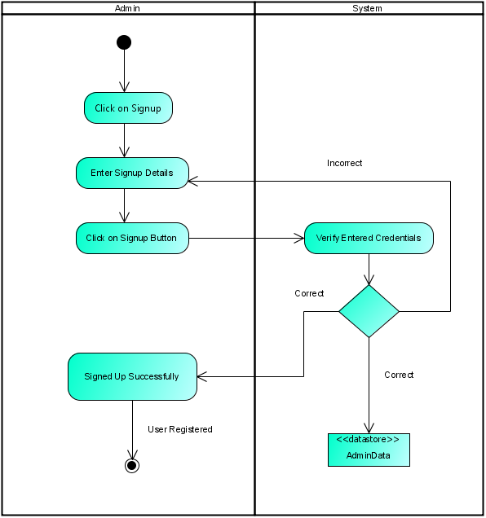

      - Admin Login
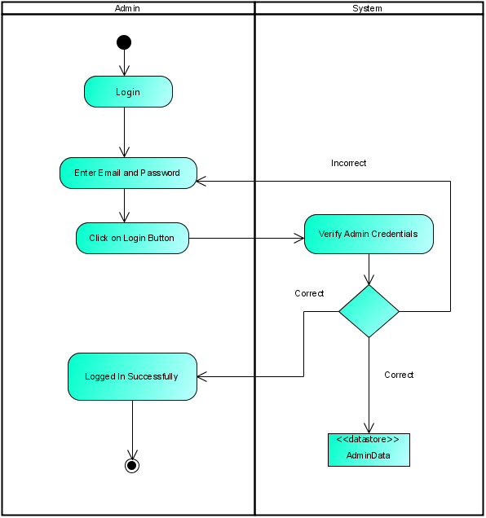

      - Admin Forgot Password
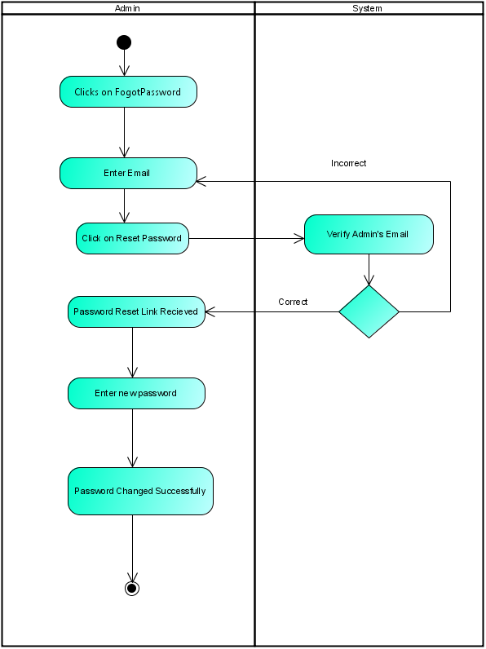

      - User Signup
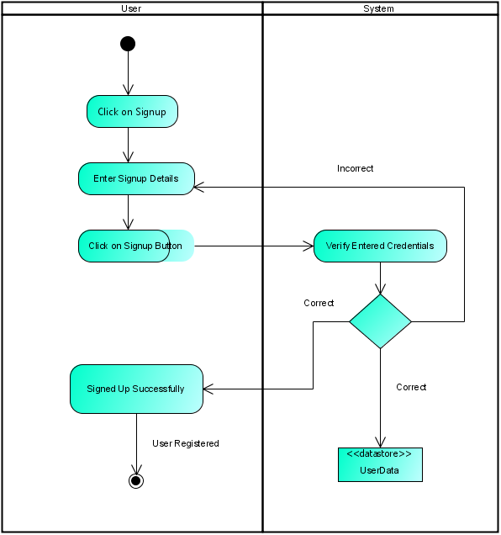

      - User Login
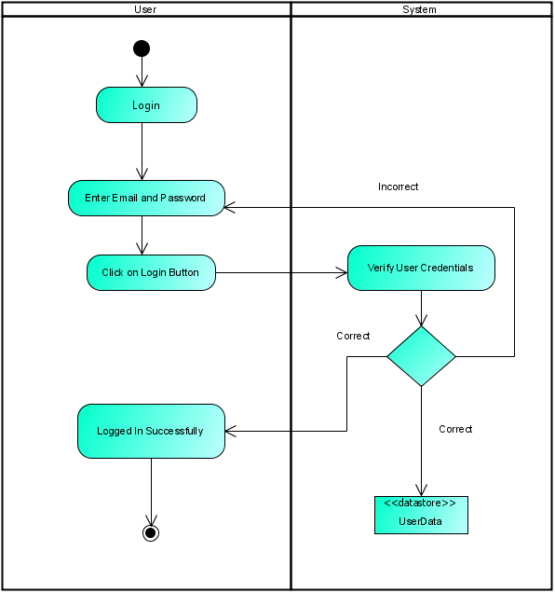

      - User Forgot Password
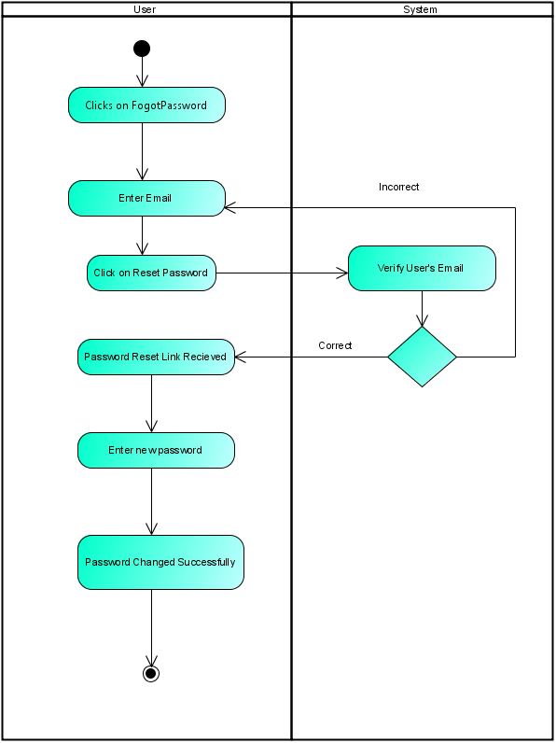

      - User Take Image
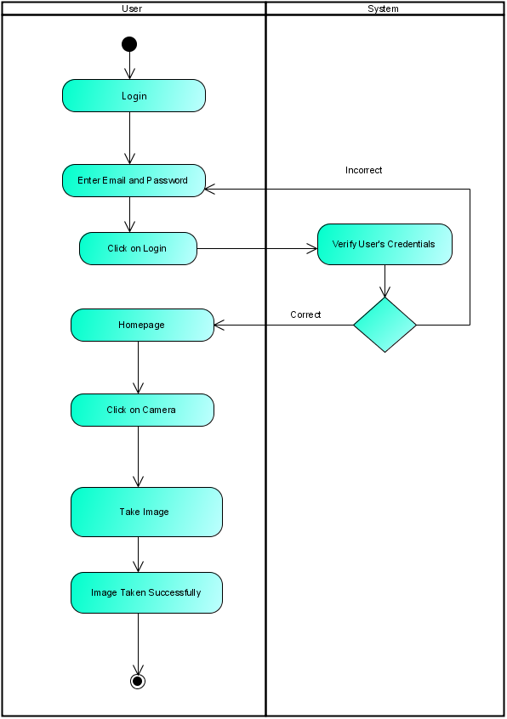
      - User Search Pharmacy
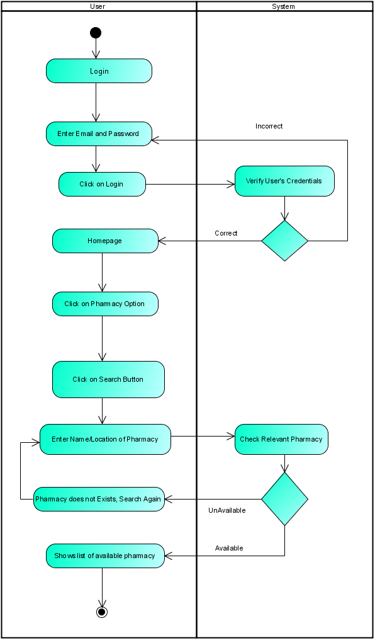

      - User View Pharmacy
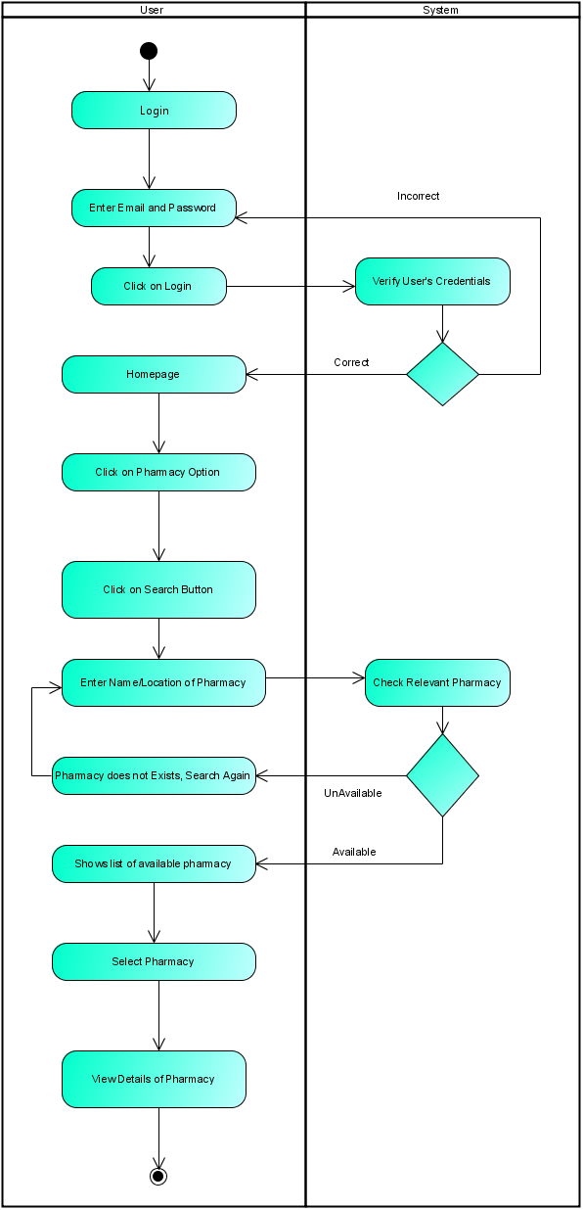

      - User View Doctor
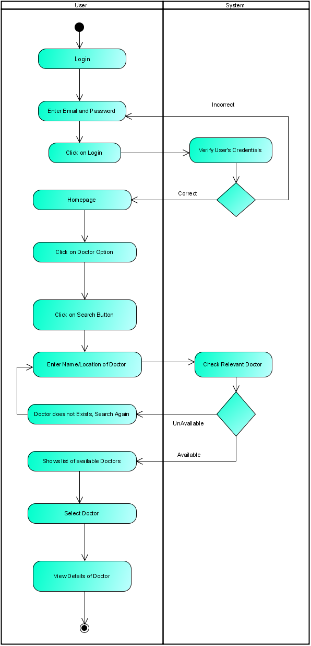

      - User Search Doctor
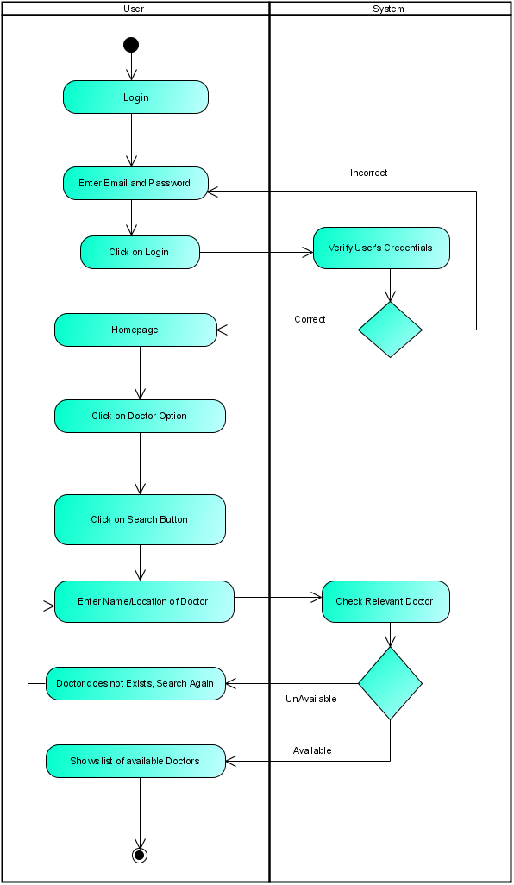
      - User Make Complaint
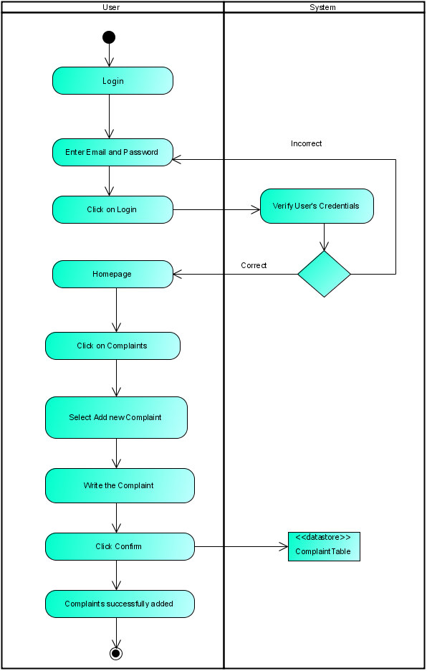
      - User Get Diagnostic Information
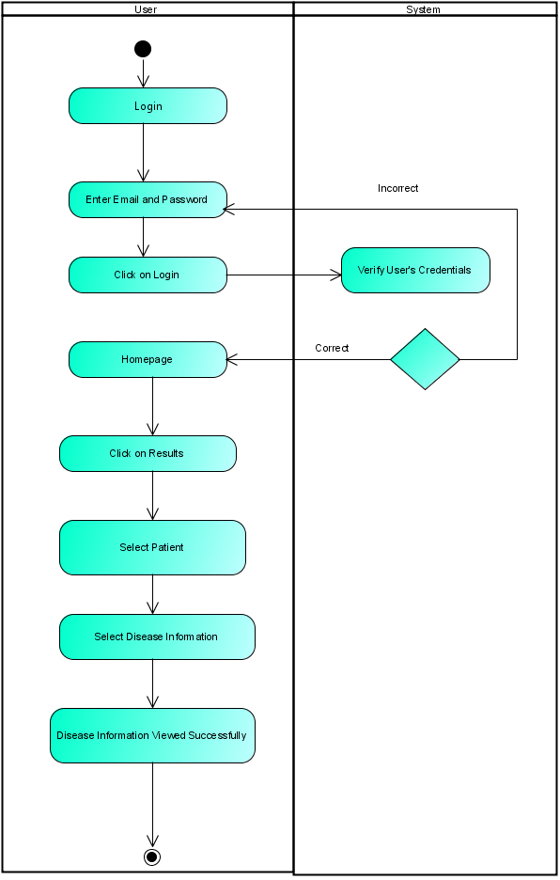

      - User View Result
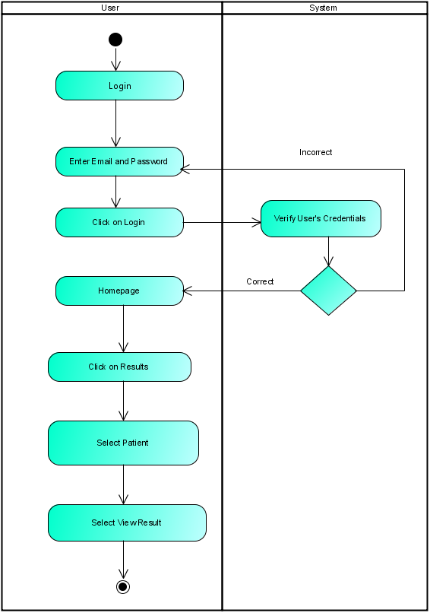

      - User Delete Result
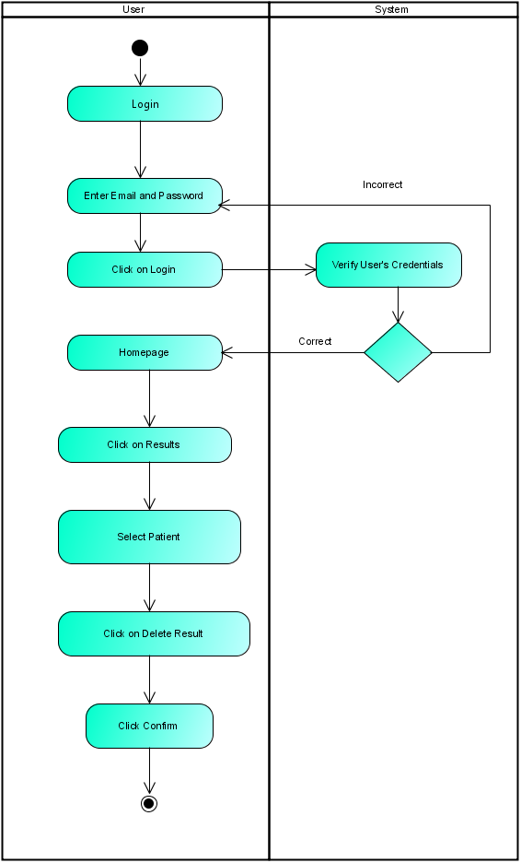

      - User Add New Patient
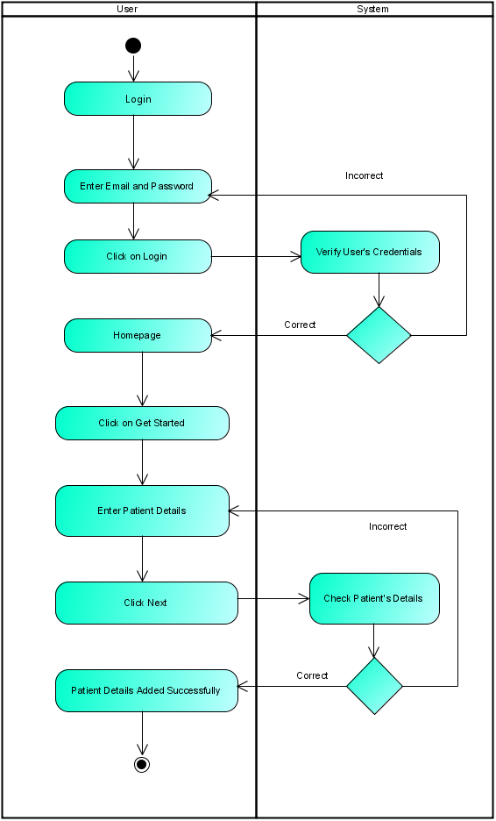
      - User Update Patient
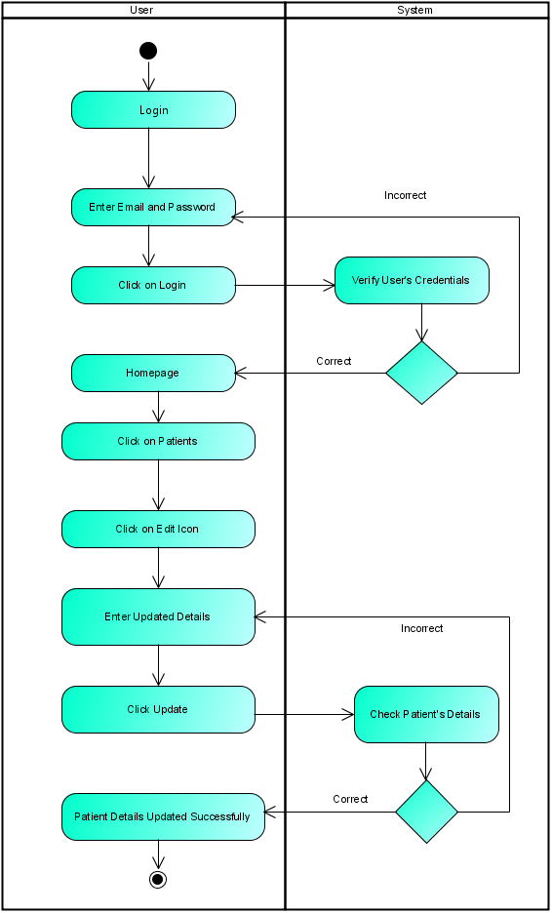
      - User View Patient Details
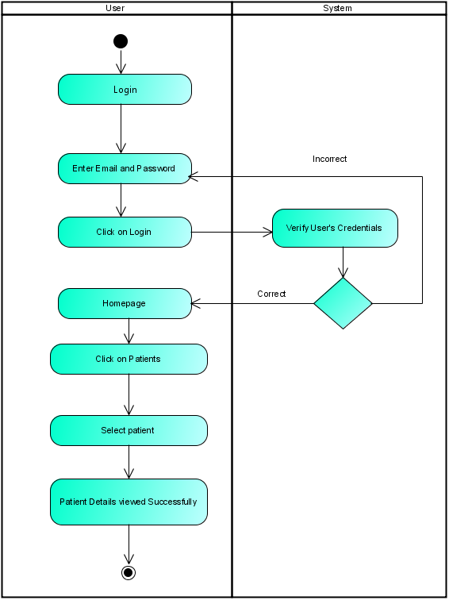
      - User Delete Patient Details
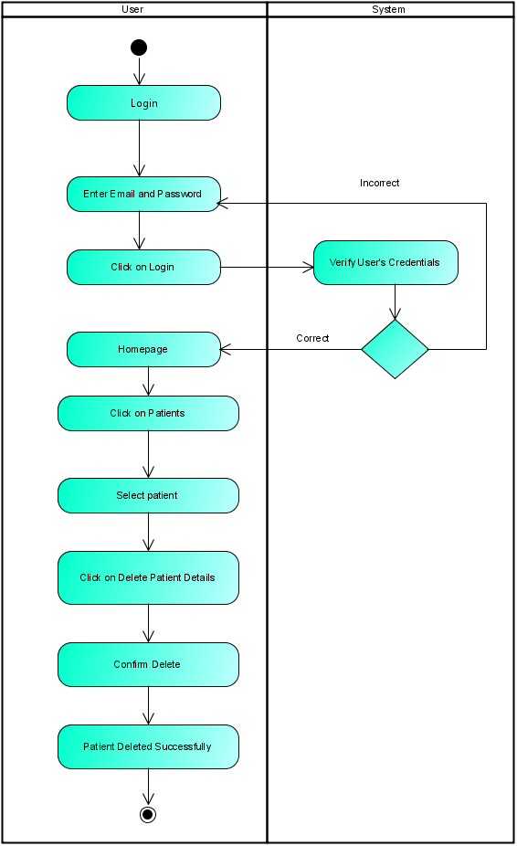
      - User Take Survey
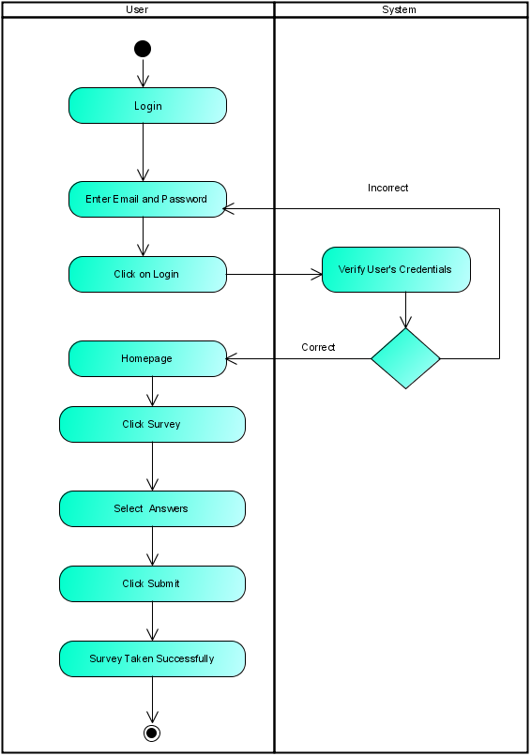
      - Admin View Complaint
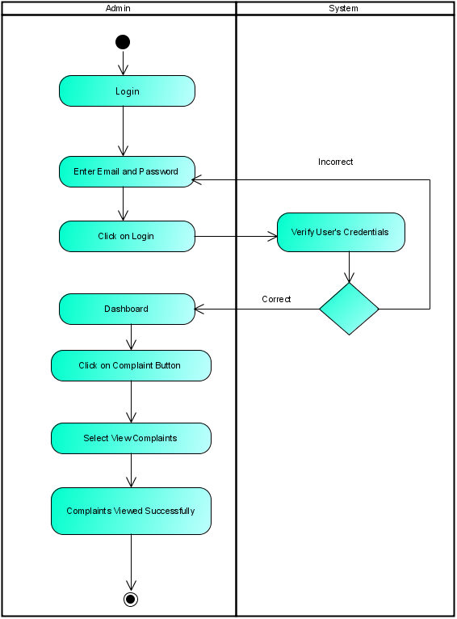
      - Admin Update Complaint
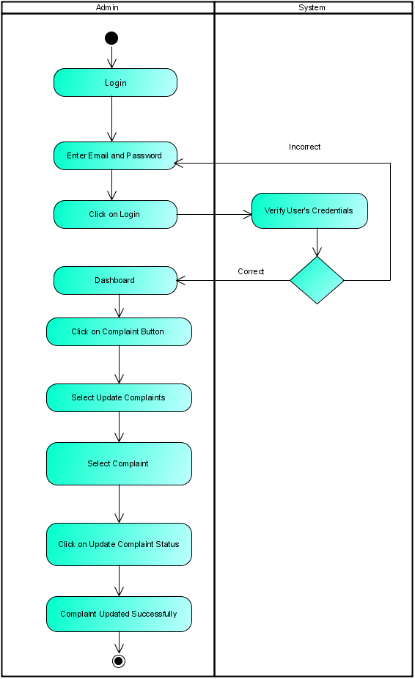
      - Admin Delete Complaint
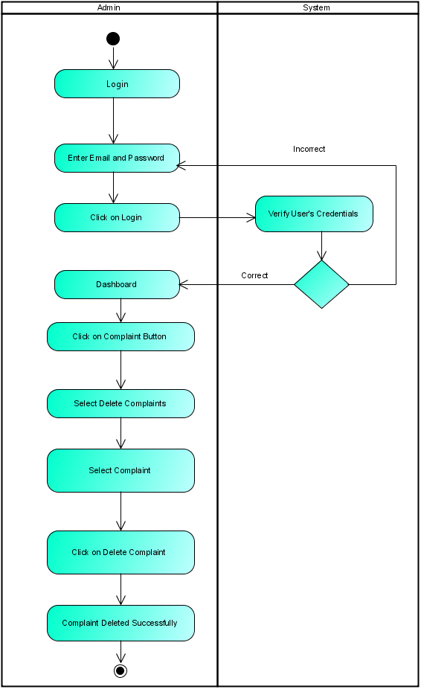
      - Admin Add Pharmacy
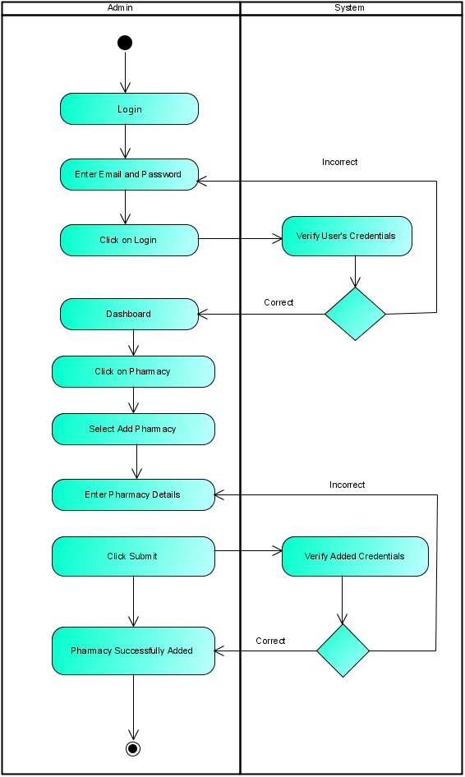
      - Admin Delete Pharmacy
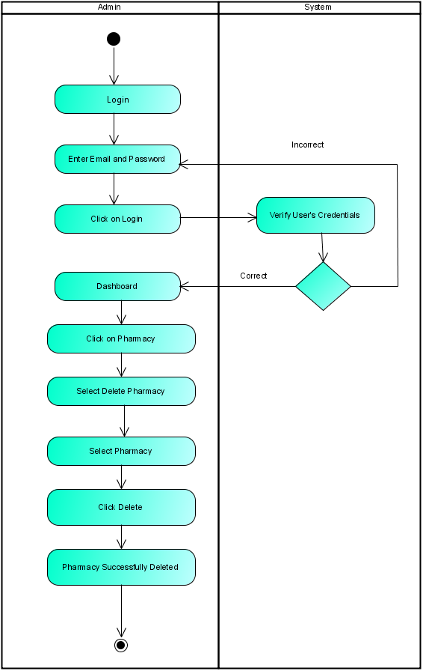
      - Admin Update Pharmacy
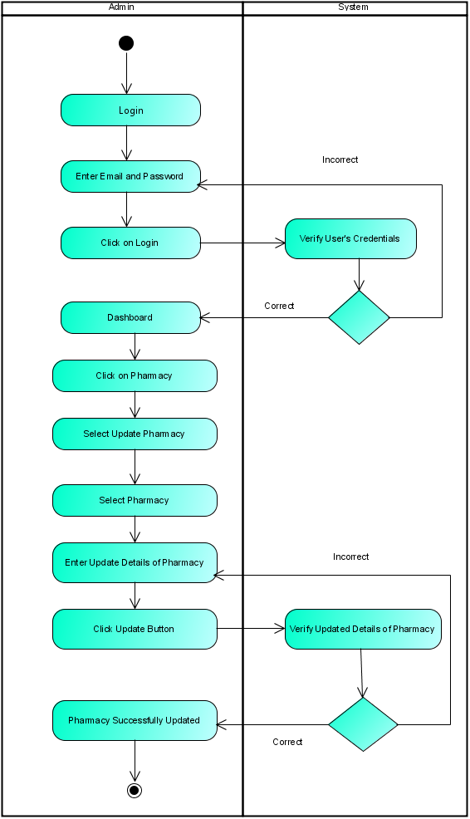
      - Admin View Patient Details
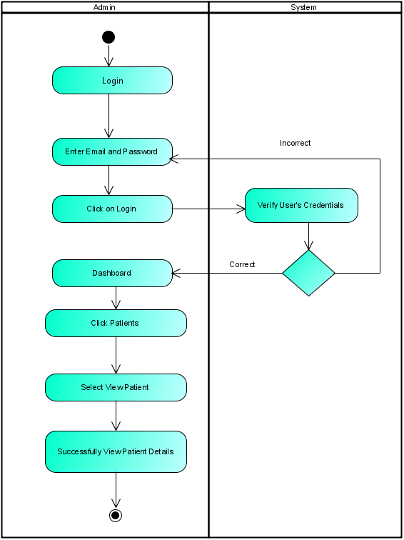
      - Admin Delete Patient Details
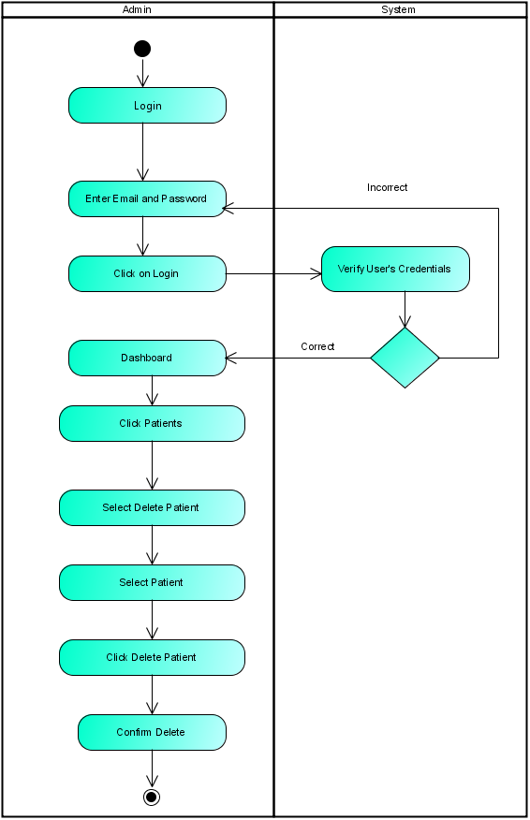
      - Admin Add Doctor
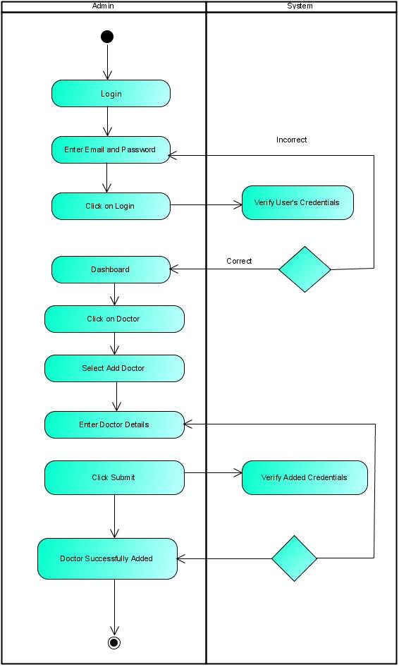
      - Admin View Doctor
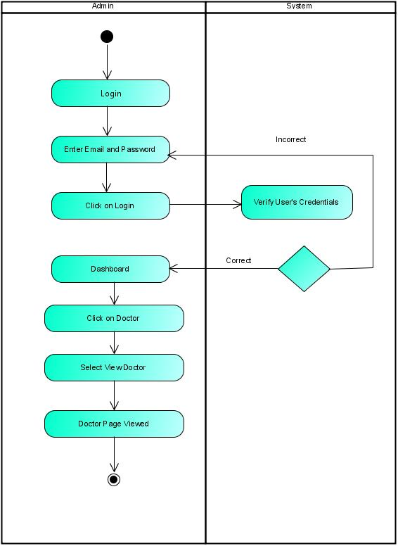
      - Admin Update Doctor
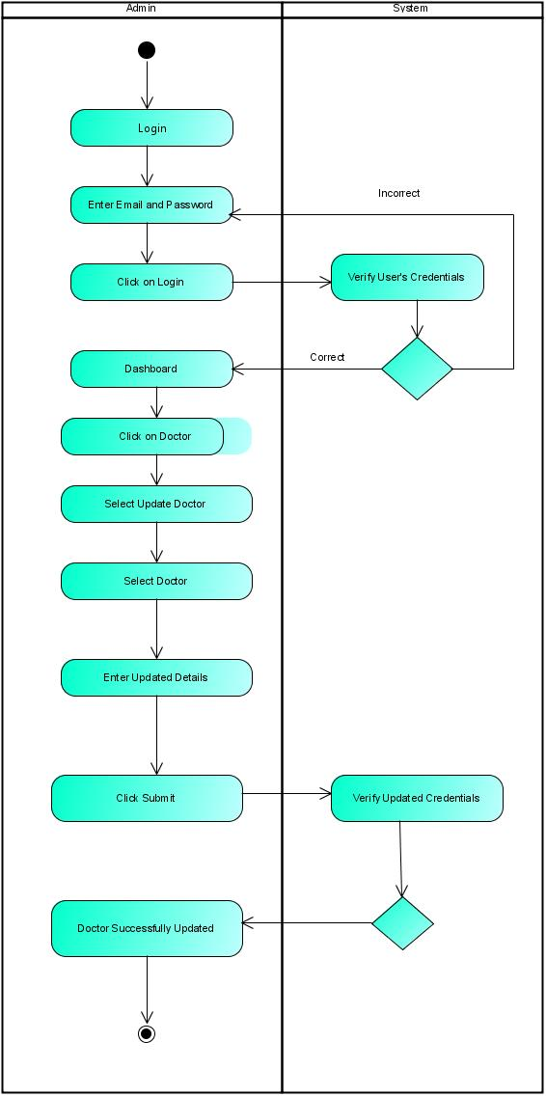
      - Admin Logout
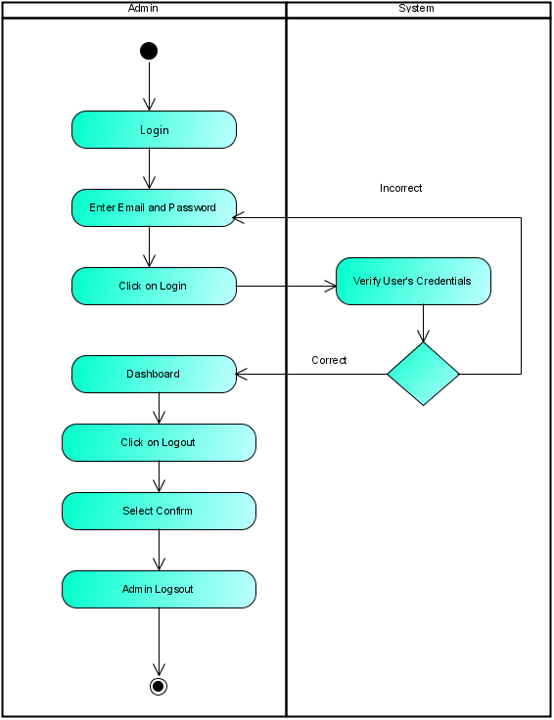
4.3.4.30 User Logout
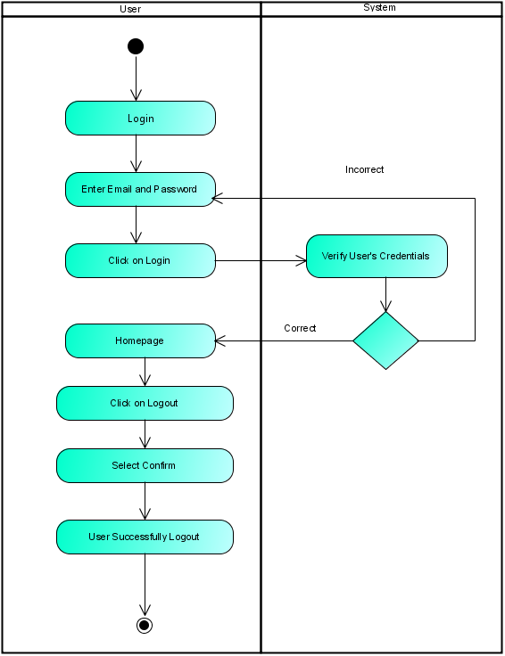

    - Sequence Diagram
We have designed sequence diagram to primarily show the interaction between objects in a sequential order that those interaction occurs. This easily makes us visualize the communication and responses of objects like hoe admin, user and system communicate.
      - User Login
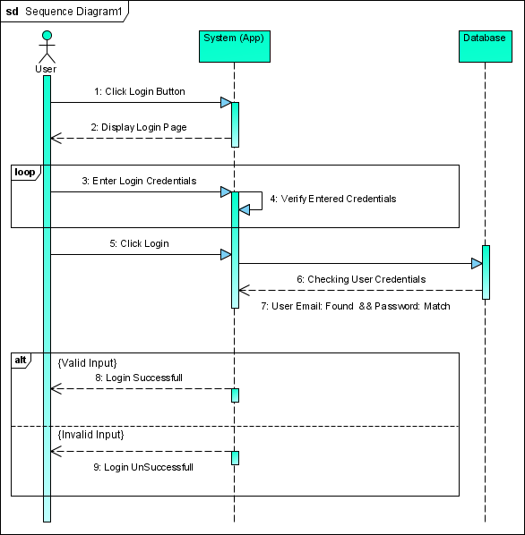
      - User Signup
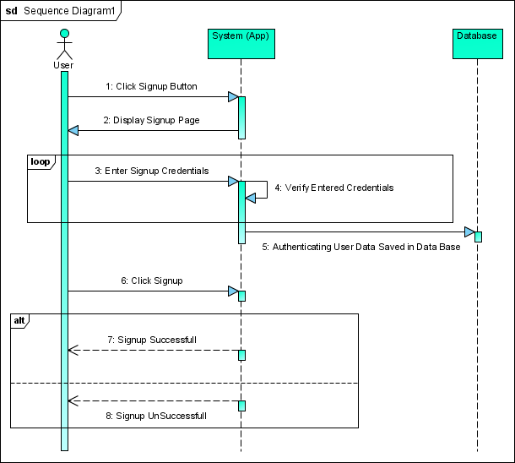

      - User Forgot Password
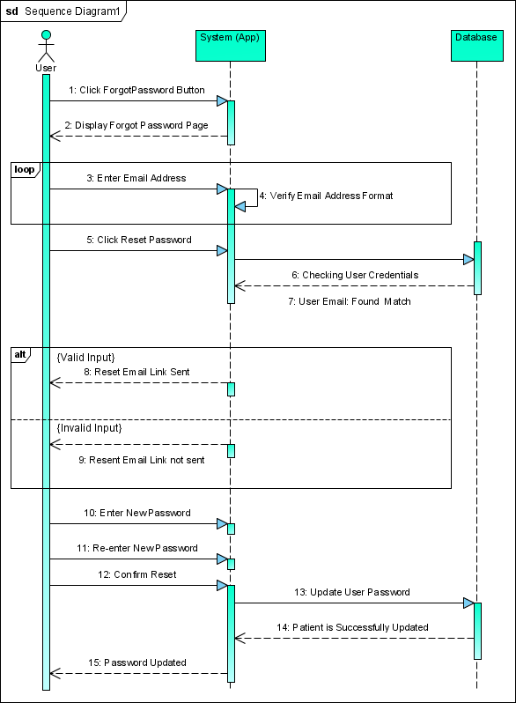

      - Admin Login
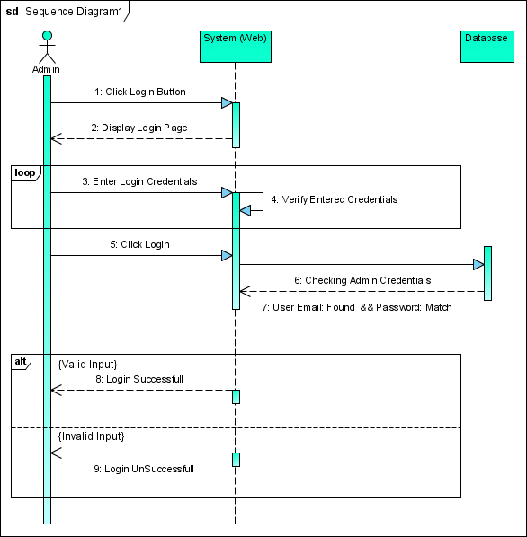

      - Admin Sign up
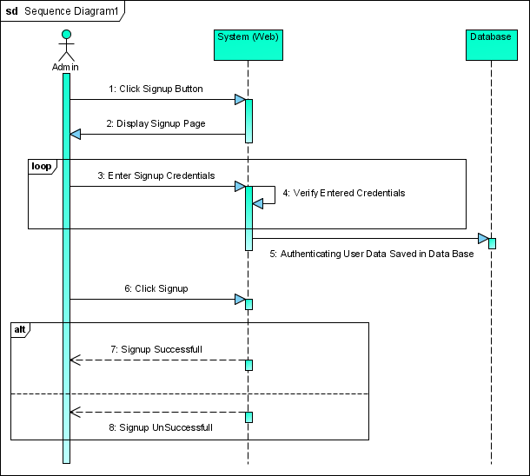

      - Admin Forgot Password
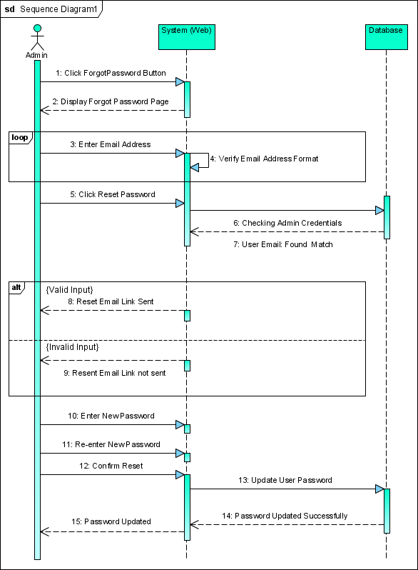

4.3.5.7 User Take Image
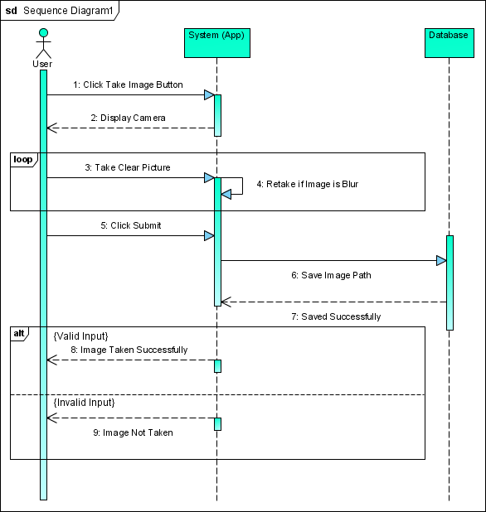

4.3.5.8 User Search Pharmacy
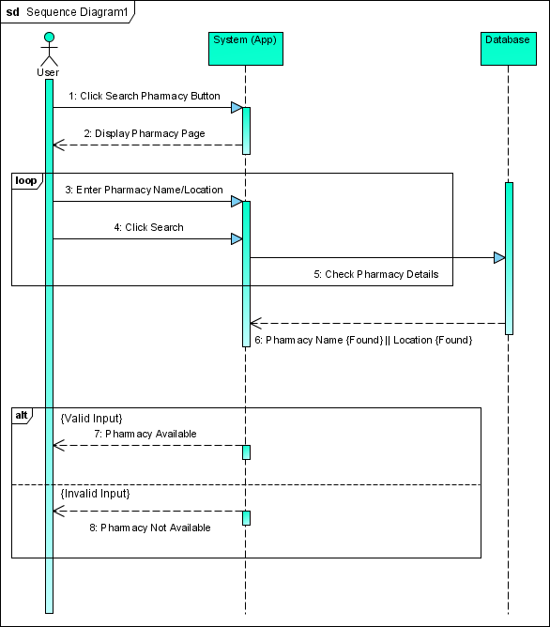

4.3.4.9 User View Pharmacy
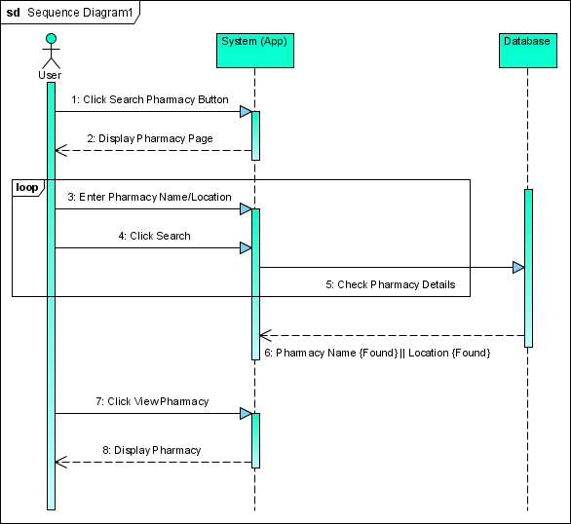

4.3.5.10 User Search Doctor
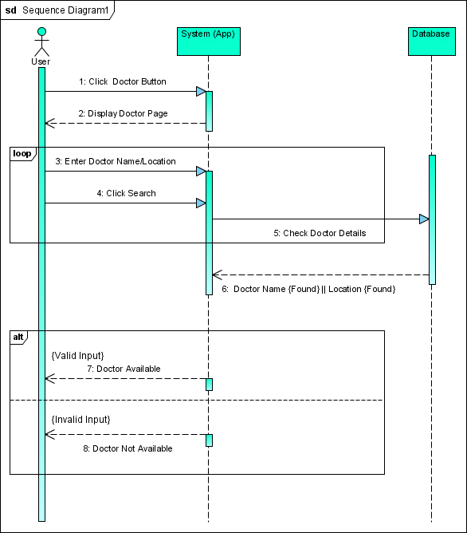

4.3.5.11 User View Doctor
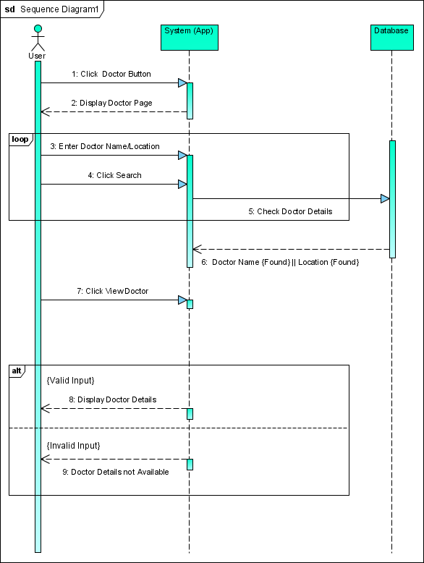

4.3.4.12 User Make Complaint
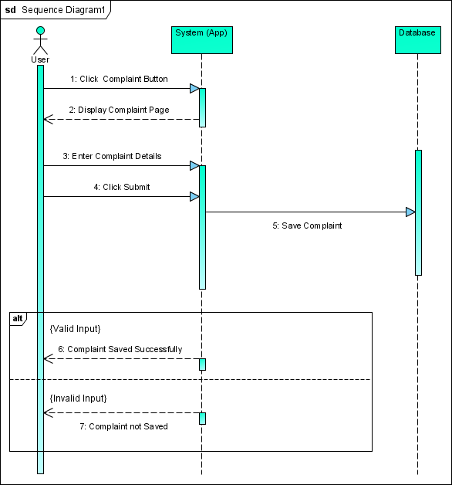

4.3.5.13 User Get Diagnostic Information
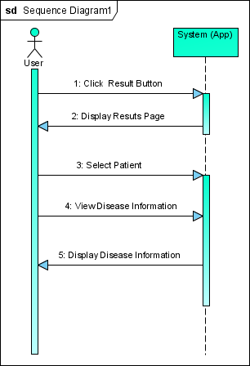

4.3.5.14 User View Result
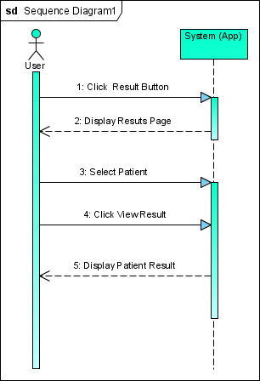

4.3.4.15 User Delete Result
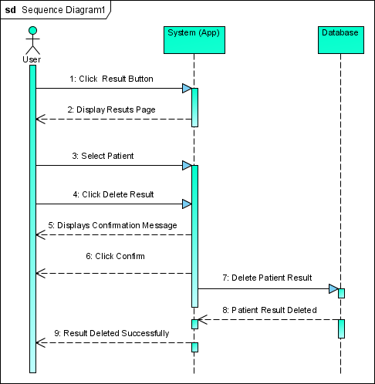

4.3.5.16 User Add New Patient
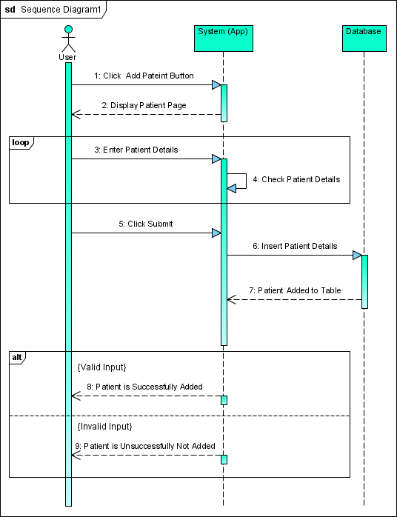

4.3.5.17 User Update Patient Details
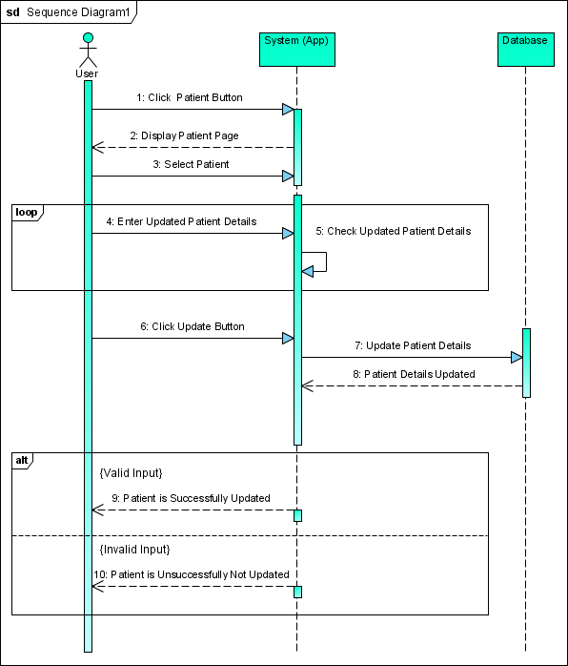

4.3.4.18 User View Patient Details
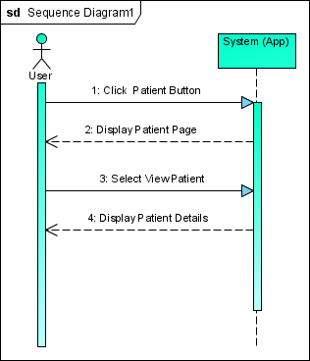

4.3.5.19 User Delete Patient Details
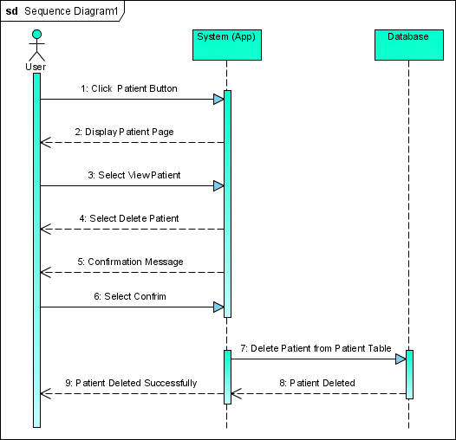

4.3.5.20 Admin View Complaints
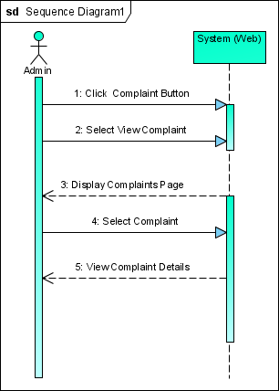

4.3.4.21 Admin Update Complaints
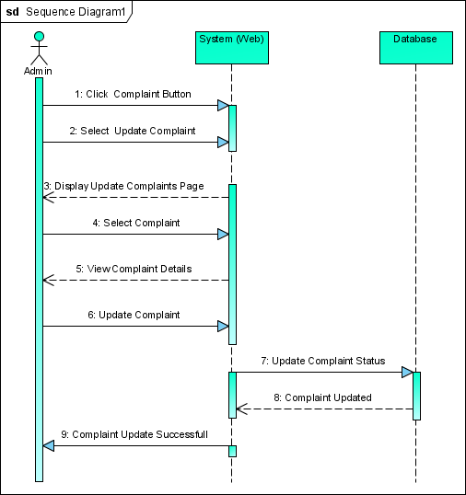

4.3.5.22 Admin Delete Complaints
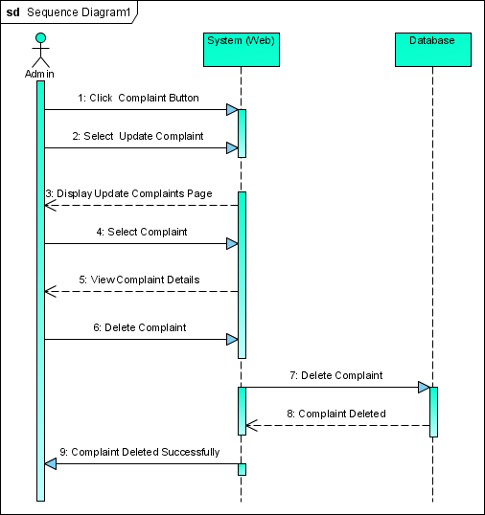

4.3.4.23 Admin Add Pharmacy
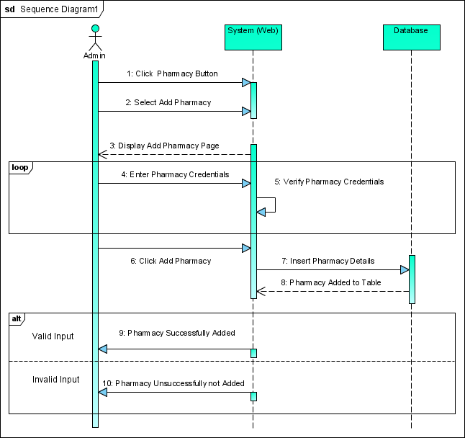

\
4.3.5.24 Admin Delete Pharmacy
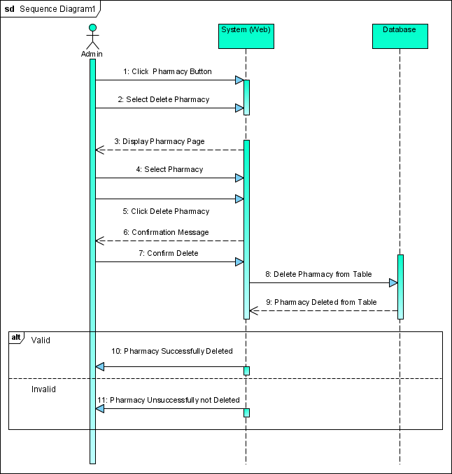

4.3.4.25 Admin Update Pharmacy
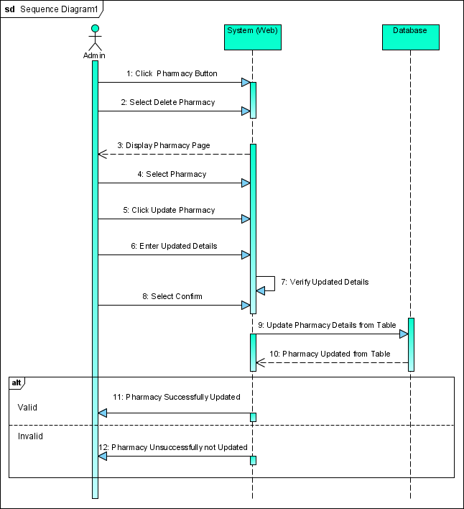

4.3.5.26 Admin View Patient Details
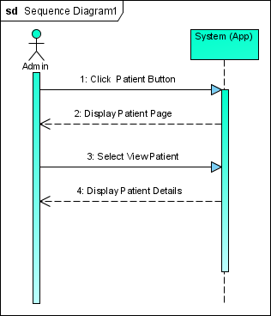

4.3.4.27 Admin Delete Patient Details
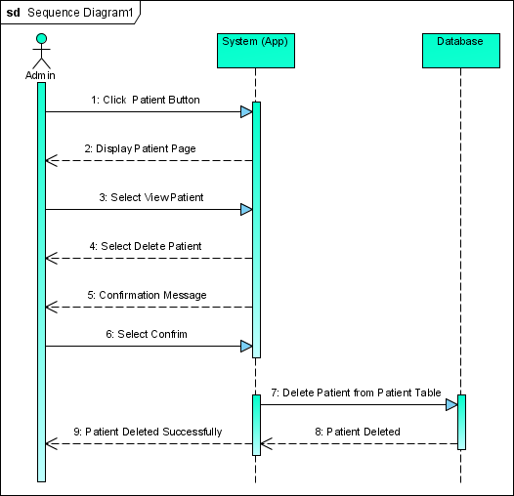

4.3.5.28 Admin Add Doctor
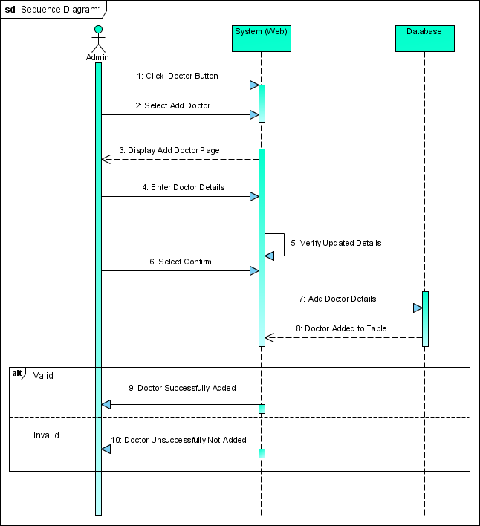

4.3.4.29 Admin Update Doctor
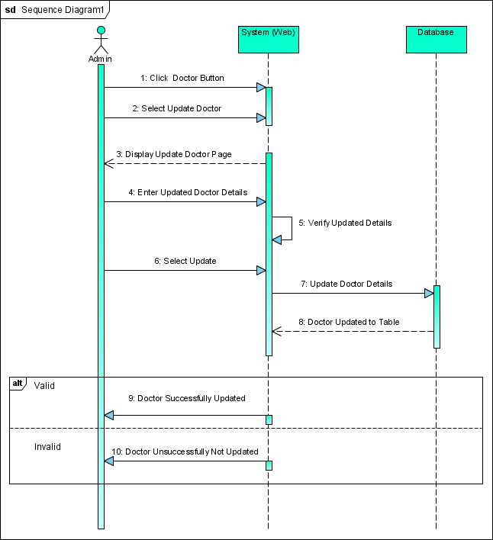

4.3.5.30 Admin Delete Doctor
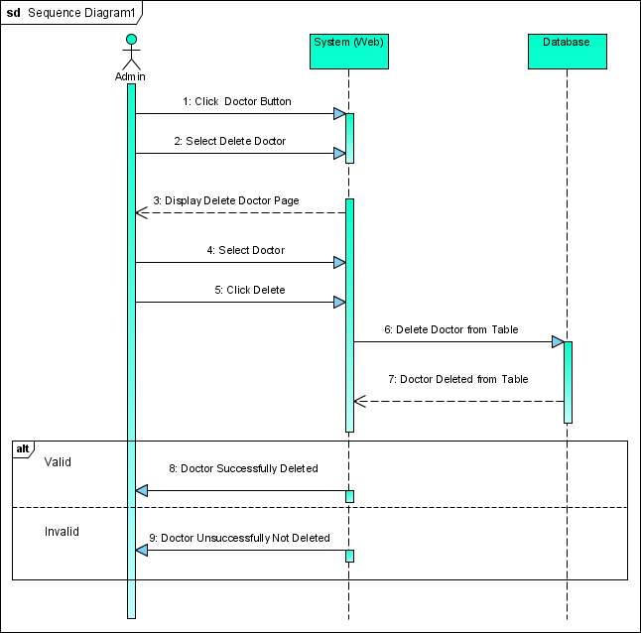

4.3.5.31 User Take Survey
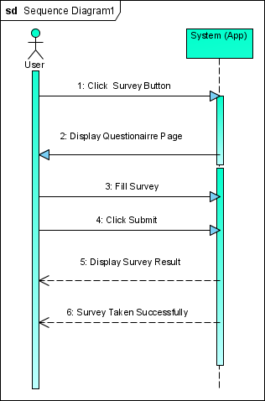

4.3.4.32 User Logout
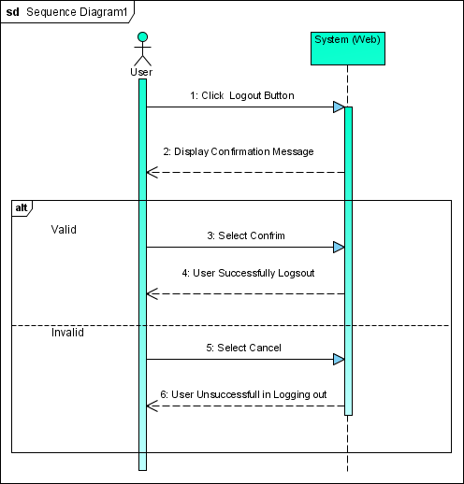

4.3.5.33 Admin Logout

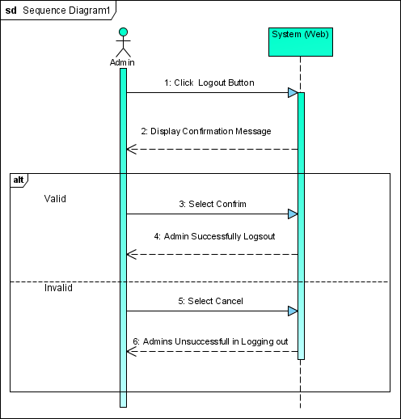

4.3.6 Data Model Diagram
Firebase is a NoSQL, document-oriented database. Unlike a SQL database, there are no tables or rows. Instead, you store data in documents, which are organized into collections.
Therefore, instead of designing Entity Relationship Diagram we have designed Data Model Diagram to visually represent the collections and the document made insides those collections. All documents must be stored in collections. Documents can contain subcollections and nested objects, both of which can include primitive fields like strings or complex objects like lists.
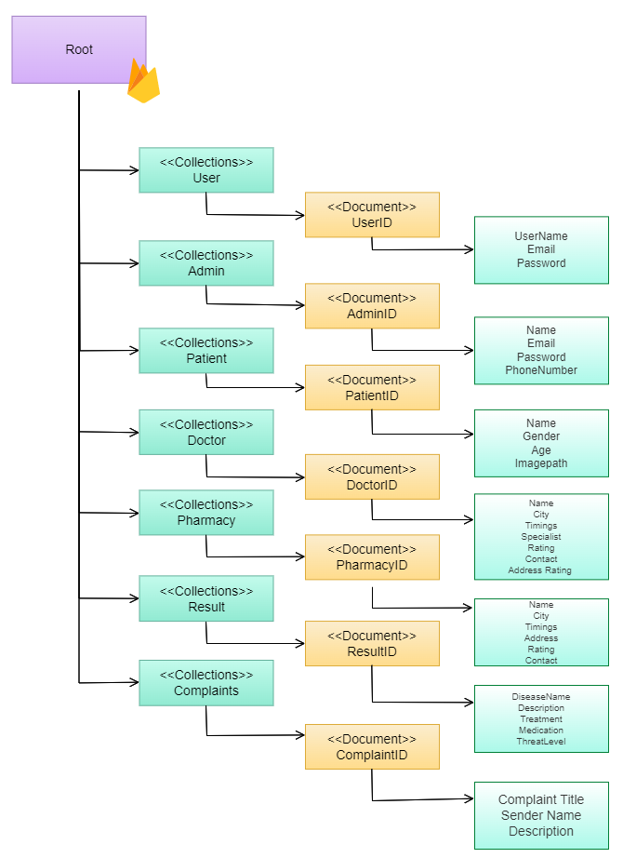

Chapter 5:
Implementation

Chapter 5
Implementation

5.1 Endeavor
5.1.1 Team
- Ali Akbar
- Salman Ahmed
- Muhmmad Haseeb

5.2 Component, Libraries, Web Services and Stub
5.2.1 Flutter
Flutter is an open-source UI software development kit created by Google. It is used to develop cross-platform applications for Android, iOS, Linux, macOS, Windows, Google Fuchsia, and the web from a single codebase

5.2.2 TensorFlow
TensorFlow is a free and open-source software library for machine learning and artificial intelligence. It can be used across a range of tasks but has a particular focus on training and inference of deep neural networks

5.2.3 Keras
Keras is an open-source software library that provides a Python interface for artificial neural networks. Keras acts as an interface for the TensorFlow library. Up until version 2.3, Keras supported multiple back ends, including TensorFlow, Microsoft Cognitive Toolkit,

5.2.4 Open CV
open-source computer vision and machine learning software library. Open CV was built to provide a common infrastructure for computer vision applications and to accelerate the use of machine perception in the commercial products.

5.3 IDE, Tools and Technologies
- Android Studio
- Atom
- Sublime Text
- Xamp Server
- MS Word
- Visual Paradigm

5.4 Database
- Firebase

5.5 Work

Sr. | WBS Derivable | Activity to  Complete | Members | Responsibility | Due Date
1.1 | Problem Identification | Brainstorming  Interviewing  Observing  Literature Review | Whole Team | Extract Problem(s) through the mentioned techniques. Place them in the proper format of problem statements. | 10th October, 2022
1.2 | System Initial Document | Brainstorming  Market Survey | Whole Team | Elicit requirements through the mentioned techniques and place them in a proper format. | 15th October, 2022
1.3 | Evaluation and Recommendation | Discussion with Supervisor  Project Proposal | Whole Team | Discussion of Additional Recommendations and maturing the idea. | 18th October, 2022
1.3.1 | Requirement Analysis | Functional Requirement Document  Requirement Elicitation  Questionnaires | Whole Team | Elicit requirements through the mentioned techniques and place them in a proper format | 30th October 2022
2.1 | System Design | Architecture Diagram | Ali Akbar | Draw out a clear diagram that shows the system behavior and elicit which environment system will work. | 5th November 2022
2.1 | System Design | Use Case Diagram | Ali Akbar |  | 10th November 2022
2.1 | System Design | Use Case Fully Dressed Format | Salman Ahmed  M. Haseeb |  | 3th December 2022
2.1 | System Design | Sequence Diagram | Salman Ahmed  M. Haseeb |  | 7th December 2022
2.1 | System Design | Activity Diagram | Salman Ahmed  M. Haseeb |  | 15th December 2022
2.1 | System Design | Class Diagram | Ali Akbar |  | 21th December 2022
2.1 | System Design | Deployment Diagram | Ali Akbar |  | 27th December 2022
2.1 | System Design | ERD Diagram | Ali Akbar |  | 29th December 2022
2.2 | Implementation | Front End Development  Back End Development  Creating API  Implementation of Algorithm | Whole Team
2.3 | Testing and Performance Evaluation | Test Case Scenario  Test Case Data | Whole Team
2.4 | System Interfaces | Admin Panel (Web)  User Panel (App) | Whole Team | Create separate web and application panels for admin and user respectively.

5.6 Best Practices/ Coding Standards
During the development phase of our application, we will imply on following practices and coding conventions:
- Following Naming Conventions
- Keeping the code modularized by one widget per dart file.
- Avoiding Hard Coded Literals
- Using Git for Version Control
- Avoiding Deep Nesting
- Using functions instead of repeated code.
- Promoting Single Responsibility Principle.

5.7 Deployment Environment

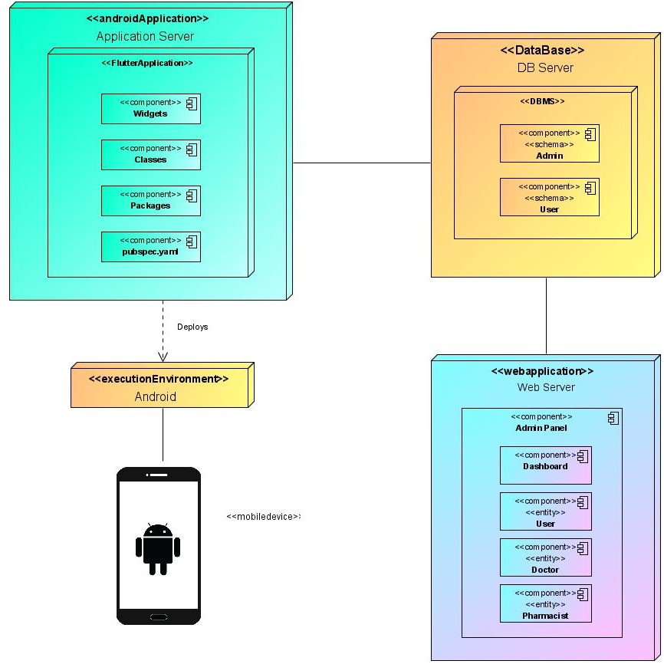

5.8 Summary

In this chapter, the basic flow control of the software been developed, its basic components, supporting libraries, development environment, required frameworks and the validation behind these selections have been discussed. The coding techniques and best practices on which the software will implement have also been discussed.

Chapter 6:
Testing and Evaluation

Chapter 6
Testing and Evaluation

6.1 Introduction

Software testing is a process of executing a program or application with the intent of finding software bugs and to check whether the actual results match the expected results ensuring a defect free software system. So, in this chapter we will discuss testing of our admin web panel as well as mobile application “Derma Vision”. We will use two approaches of testing. First is the black box testing and second is white box testing. In black box testing we will examine functionality of an application from requirements without looking at the code structure. And in the next sections we will do white box testing.

6.2 List of Test Scenarios
In this section we will cover all the test data and test cases of all the stakeholders involved in our system. Following are the list of all test data and test cases.

Test Data Admin:

1)

ID | TD-01.1
Requirement | FR-01.1
Form | Admin Signup
Stakeholder | Admin
Field | Username
Technique | Equivalence Class Partitioning
Valid | - {{a, b, c …z}, {A, B, C …Z}, {0,1 2, 3 …9}}  - Empty spaces are not allowed with alphanumeric.  - 3≤character≤40
Invalid | - Arithmetic Symbols.  - Special characters  - character < 3 and character > 40  - Alphanumeric spaces.

2)

ID | TD-01.2
Requirement | FR-01.1
Form | Admin Signup
Stakeholder | Admin
Field | Email
Technique | Equivalence Class Partitioning
Valid | - {{a,b,c....z},{A,B,C…Z},{0,1,2,3…9} and period(.) are allowed for email before domain name.  - The First and Last character of your username must be an letter {{a,b,c....z},{A,B ,C…Z}}or number {0,1,2,3…9} before ‘domain name’  - Username must be between 6 and 30 characters long.
Invalid | - Special characters and Arithmetic Characters before ‘domain name’  - Missing Username  - Periods (.) is put on the First or on the Last Characters of Username before ‘domain name.  - Username Characters < 6 and Username Characters > 30

3)

ID | TD-01.3
Requirement | FR-01.1
Form | Admin Signup
Stakeholder | Admin
Field | Contact Number
Technique | Equivalence Class Partitioning
Valid | - {0,1,2,3,4,5,6,7,8,9}  - Length=11
Invalid | - {a,b,c,d,e,f,….z}  - Arithmetic Symbols  - Special Characters  - Length != 11

4)

ID | TD-01.4
Requirement | FR-01.1
Form | Admin Signup
Stakeholder | Admin
Field | Password
Technique | Equivalence Class Partitioning
Valid | - Password length >= 8  Must contain at least  - One uppercase letter  - One lowercase letter  - One Numeric character  - One Special Character
Invalid | - Password length < 8  - No uppercase Alphabets  - No lowercase alphabets  - No numeric character  - No special Character

5)

ID | TD-01.5
Requirement | FR-01.1
Form | Admin Signup
Stakeholder | Admin
Field | Confirm Password
Technique | Equivalence Class Partitioning
Valid | - Re-entered Password is equal to the entered Password.
Invalid | - Re-entered Password is not equal to the entered Password.

6)

ID | TD-01.6
Requirement | FR-01.2
Form | Admin Login
Stakeholder | Admin
Field | Email
Technique | Equivalence Class Partitioning
Valid | - salmanahmed7866@gmail.com  - salman.ahmed7866@gmail.com
Invalid | - salman-ahmed7866@gmail.com  - salmanahmed_7866@gmail.com  - .salman_ahmed7866@gmail.com

7)

ID | TD-01.7
Requirement | FR-01.2
Form | Admin Login
Stakeholder | Admin
Field | Password
Technique | Equivalence Class Partitioning
Valid | - Salman@123
Invalid | - Other than Valid

User Test Data:

8)

ID | TD-1.8
Requirement | FR-01.3
Form | Sign up
Stakeholder | User
Field | Username
Technique | Equivalence Class Partitioning
Valid | - {{a, b, c …z}, {A, B, C …Z},{0,1 2, 3 …9}}  - Empty spaces are not allowed with alphanumeric.  - 3≤character≤40
Invalid | - Arithmetic Symbols.  - Special characters  - character < 3 and character > 40  - Alphanumeric spaces.

9)

ID | TD-01.9
Requirement | FR-01.3
Form | User Sign-up
Stakeholder | Username
Field | Email
Technique | Equivalence Class Partitioning
Valid | - {{a,b,c....z},{A,B,C…Z},{0,1,2,3…9} and period(.) are allowed for email before domain name.  - The First and Last character of your username must be an letter {{a,b,c....z},{A,B ,C…Z}}or number {0,1,2,3…9} before ‘domain name’  - Username must be between 6 and 30 characters long.
Invalid | - Special characters and Arithmetic Characters before ‘domain name’  - Missing Username  - Periods (.) is put on the First or on the Last Characters of Username before ‘@gmail.com’.  - Username Characters < 6 and Username Characters > 30

10)

ID | TD-01.10
Requirement | FR-1.3
Form | User Signup
Stakeholder | User
Field | Contact Number
Technique | Equivalence Class Partitioning
Valid | - {0,1,2,3,4,5,6,7,8,9}  - Length=11
Invalid | - {a,b,c,d,e,f,….z}  - Arithmetic Symbols  - Special Characters  - Length != 11

11)

ID | TD-1.11
Requirement | FR-1.3
Form | User Signup
Stakeholder | User
Field | Password
Technique | Equivalence Class Partitioning
Valid | - Password length >= 8  Must contain at least  - One uppercase letter  - One lowercase letter  - One Numeric character  - One Special Character
Invalid | - Password length < 8  - No uppercase Alphabets  - No lowercase alphabets  - No numeric character  - No special Character

12)

ID | TD-1.12
Requirement | FR-1.3
Form | User Signup
Stakeholder | User
Field | Confirm Password
Technique | Equivalence Class Partitioning
Valid | - Confirm Password is equal to the entered Password.
Invalid | - Confirm Password is not equal to the entered Password.

13

ID | TD-1.13
Requirement | FR-1.4
Form | User Login
Stakeholder | User
Field | Email
Technique | Equivalence Class Partitioning
Valid | - salmanahmed7866@gmail.com  - salman.ahmed7866@gmail.com
Invalid | - salman-ahmed7866@gmail.com  - salmanahmed_7866@gmail.com  - .salman_ahmed7866@gmail.com

14)

ID | TD-1.14
Requirement | FR-1.4
Form | Admin Login
Stakeholder | Admin
Field | Password
Technique | Equivalence Class Partitioning
Valid | - Salman@123
Invalid | - Other than Valid

Pharmacy details
15)
ID | TD-1.15
Requirement | FR-1.11
Form | Add Pharmacy details
Stakeholder | Admin
Field | Pharmacy Name
Technique | Equivalence Class Partitioning
Valid | - {A,b,c,d,…z},{a,b,c,d,….z}  - Empty Spaces are allowed between characters  - Length <= 30
Invalid | - Numeric character {0,1,2,3 …9}  - Special Character  - Arithmetic symbols.  - Length >30

16)

ID | TD-1.16
Requirement | FR-01.11
Form | Add Pharmacy details
Stakeholder | Admin
Field | City
Technique | Equivalence Class Partitioning
Valid | - {A,b,c,d,…z},{a,b,c,d,….z}  - Empty Spaces are not allowed between characters  - Length <= 20
Invalid | - Numeric character {0,1,2,3 …9}  - Special Character  - Arithmetic symbols.  - Length >20

17)

ID | TD-1.17
Requirement | FR-01.11
Form | Add Pharmacy details
Stakeholder | Admin
Field | Contact Number
Technique | Equivalence Class Partitioning
Valid | - {0,1,2,3,4,5,6,7,8,9}  - Length=11
Invalid | - {a,b,c,d,e,f,….z}  - Arithmetic Symbols  - Special Characters  - Length != 11

18)

ID | TD-1.18
Requirement | FR-1.11
Form | Add Pharmacy details
Stakeholder | Admin
Field | Address
Technique | Equivalence Class Partitioning
Valid | - Street, apartment, sector/block, state, zip code are need to be filled in this field.  - {a,b,c,d,…z},{A,B,C…Z},{0,1,2,3…9} and Arithmetic symbols are allowed in the address field.  - Empty Spaces and special characters are allowed between characters.  - Length <= 50
Invalid | - Length >50

19)

ID | TD-1.19
Requirement | FR-01.11
Form | Add Pharmacy details
Stakeholder | Admin
Field | Timings
Technique | Equivalence Class Partitioning
Valid | - Only numeric values {0,1,2,3…9}  - Length =8  - 12hr time format HH: MM XM
Invalid | - Length >8  - 24hr time format HH: MM  - Special character  - Arithmetic symbols  - Alphabets

20)

ID | TD-1.20
Requirement | FR-01.11
Form | Add Pharmacy details
Stakeholder | Admin
Field | Rating
Technique | Equivalence Class Partitioning
Valid | - Only numeric values{0,1,2,3…9}  - Length =1
Invalid | - Length >1  - Special character  - Arithmetic symbols  - Alphabets

Add Doctor Details
21)

ID | TD-1.21
Requirement | FR-01.13
Form | Add Doctor
Stakeholder | Admin
Field | Name
Technique | Equivalence Class Partitioning
Valid | - {A,b,c,d,…z},{a,b,c,d,….z}  - Empty Spaces are allowed between characters  - Length <= 30
Invalid | - Numeric character {0,1,2,3 …9}  - Special Character

22)

ID | TD-1.22
Requirement | FR-01.13
Form | Add Doctor
Stakeholder | Admin
Field | Specialist
Technique | Equivalence Class Partitioning
Valid | - {A,b,c,d,…z},{a,b,c,d,….z}  - Empty Spaces are allowed between characters  - Length <= 30
Invalid | - Numeric character {0,1,2,3 …9}  - Special Character

23)

ID | TD-1.23
Requirement | FR-01.13
Form | Add Doctor
Stakeholder | Admin
Field | Contact Number
Technique | Equivalence Class Partitioning
Valid | - {0,1,2,3,4,5,6,7,8,9}  - Length=11
Invalid | - {a,b,c,d,e,f,….z}  - Arithmetic Symbols  - Special Characters  - Length != 11

24)

ID | TD-1.24
Requirement | FR-01.13
Form | Add Doctor
Stakeholder | Admin
Field | Address
Technique | Equivalence Class Partitioning
Valid | - Street, apartment, sector/block, state, zip code are need to be filled in this field.  - {a,b,c,d,…z},{A,B,C…Z},{0,1,2,3…9} and Arithmetic symbols are allowed in the address field.  - Empty Spaces and special characters are allowed between characters.  - Length <= 50
Invalid | - Length >50

25)

ID | TD-1.25
Requirement | FR-01.13
Form | Add Doctor
Stakeholder | Admin
Field | Timings
Technique | Equivalence Class Partitioning
Valid | - Only numeric values {0,1,2,3…9}  - Length =8  - 12hr time format HH: MM XM
Invalid | - Length >8  - 24hr time format HH: MM  - Special character  - Arithmetic symbols  - Alphabets

26)

ID | TD-1.26
Requirement | FR-01.13
Form | Add Doctor
Stakeholder | Admin
Field | Fees
Technique | Equivalence Class Partitioning
Valid | - Only numeric values {0,1,2,3…9}  - Length =5
Invalid | - Length >5  - Special character  - Arithmetic symbols  - Alphabets

27)

ID | TD-1.27
Requirement | FR-01.13
Form | Add Doctor
Stakeholder | Admin
Field | Rating
Technique | Equivalence Class Partitioning
Valid | - Only numeric values{0,1,2,3…9}  - Length =1
Invalid | - Length >1  - Special character  - Arithmetic symbols  - Alphabets

6.3 Performance & Evaluation.
In this section we will evaluate our system based on above generated test data and will discuss the result of Evaluation.

Test Case Design:
ID | TD-01.1
Requirement | FR-01.1
Form | Admin Signup
Stakeholder | Admin
Field | Username
Technique | Equivalence Class Partitioning
input | Salman_ahmed7866 | Salmanahmed7866 | Salman ahmed7866
Partition Tested | Special characters are not allowed. | {a, b, c …z},  {A, B,C…Z},  {0,1 2, 3 …9} | Empty spaces are not allowed.
Expected output | Error message | OK | Error message
Observed Output | Error message | OK | Error message

ID | TD-01.2
Requirement | FR-01.1
Form | Admin Signup
Stakeholder | Admin
Field | Email
Technique | Equivalence Class Partitioning
input | Ali.Akber2@gmail.com | Ali_Akber7@gmail.com | . AliAkber@gmail.com
Partition Tested | Ali.Akber2@gmail.com | Special characters and Arithmetic Characters are not allowed before ‘domain name’ | Period(.) is not allowed at the start of the username.
Expected output | OK | Error Message | Error message
Observed Output | OK | Error Message | Error message

ID | TD-01.3
Requirement | FR-01.1
Form | Admin Signup
Stakeholder | Admin
Field | Contact Number
Technique | Equivalence Class Partitioning
input | 03425181786 | 0342-5181786 | 0342518178
Partition Tested | Only Numeric values {0,1,2,3,4,5,6,7,8,9} are allowed and Length=11 | Special characters and Arithmetic Characters are not allowed anywhere. | Length should be 11 digit.
Expected output | OK | Error Message | Error message
Observed Output | OK | Error Message | Error message

ID | TD-01.4
Requirement | FR-01.1
Form | Admin Signup
Stakeholder | Admin
Field | Password
Technique | Equivalence Class Partitioning
input | Pakistan@123 | pakistan@123 | Pakistan123
Partition Tested | 1.Password length >= 8  Must contain at least  1. One uppercase letter  2. One lowercase letter  3. One Numeric character  4. One Special Character | 1.Password length >= 8  Must contain at least  1. One uppercase letter  2. One lowercase letter  3. One Numeric character  4. One Special Character | 1.Password length >= 8  Must contain at least  1. One uppercase letter  2. One lowercase letter  3. One Numeric character  4. One Special Character
Expected output | OK | Error Message | Error message
Observed Output | OK | Error Message | Error message

ID | TC-1.5
Requirement | FR-01.1
stakeholder | Admin Signup
Form | Signup
Field | Confirm Password
Technique | Equivalence Class Partitioning
Input | Pakistan@123 | Apple@123
Partition Tested | Re-entered Password is equal to the entered Password. | Re-entered Password is not equal to the entered Password.
Expected Output | OK | Error Message
Observed Output | OK | Error Message

ID | TC-1.6
Requirement | FR-01.2
stakeholder | Admin
Form | Login
Field | Email
Technique | Equivalence Class Partitioning
Input | Ali.Akber2@gmail.com | Ali.Akber7@gmail.com
Partition Tested | Ali.Akber2@gmail.com | Other than valid
Expected Output | OK | Error Message
Observed Output | OK | Error Message

ID | TC-01.7
Requirement | FR-01.2
stakeholder | Admin
Form | Login
Field | Password
Technique | Equivalence Class Partitioning
Input | Pakistan@123 | Apple@123
Partition Tested | Pakistan@123 | Other than valid
Expected Output | OK | Error Message
Observed Output | OK | Error Message

Pharmacy details

ID | TD-01.8
Requirement | FR-01.11
Form | Add Pharmacy details
Stakeholder | Admin
Field | Pharmacy Name
Technique | Equivalence Class Partitioning
input | Standard Pharmacy | Standard Pharmacy | Standard Pharmacy24
Partition Tested | - {A,b,c,d,…z},  {a,b,c,d,….z}  - Empty Spaces are allowed between characters  - Length <= 30 | Special Character is not allowed. | Numeric characters  {0,1,2,3 …9} are not allowed.
Expected output | OK | Error Message | Error message
Observed Output | OK | Error Message | Error message

ID | TD-01.9
Requirement | FR-01.11
Form | Add Pharmacy details
Stakeholder | Admin
Field | Address
Technique | Equivalence Class Partitioning
input | Street # 27,house # 252,sector # G10,Islamabad. | Street # 27,house # 252, Sector # 1, Gulshan Abad, RWP. | Street # 27, house # 252, Sector # 1, near govt high school, RWP.
Partition Tested | {a,b,c,d,…z},{A,B,C…Z},{0,1,2,3…9} and Arithmetic symbols are allowed in the address field. | {a,b,c,d,…z},{A,B,C…Z},{0,1,2,3…9} and Arithmetic symbols are allowed in the address field. | Length should be less than or equal 50.
Expected output | OK | Ok | Error message
Observed Output | OK | OK | Error message

ID | TD-01.10
Requirement | FR-01.11
Form | Add Pharmacy details
Stakeholder | Admin
Field | city
Technique | Equivalence Class Partitioning
input | Rawalpindi | rawalpindi | Rawalpindi_RWP
Partition Tested | - {A,b,c,d,…z},  {a,b,c,d,….z}  - Empty Spaces are not allowed between characters  - Length <= 20 | {A,b,c,d,…z},  {a,b,c,d,….z} | Special Characters are not allowed.
Expected output | OK | OK | Error message
Observed Output | OK | OK | Error message

ID | TD-01.4
Requirement | FR-01.11
Form | Add Pharmacy details
Stakeholder | Admin
Field | Timings
Technique | Equivalence Class Partitioning
input | 09:00am - 06:00pm | 15:00 - 22:00 | 15:00 - 22:0$
Partition Tested | - Only numeric values {0,1,2,3…9}  - Length =8  - 12hr time format HH: MM XM | 24hr time format  HH: MM is not allowed. | Special Characters are not allowed.
Expected output | OK | Error message | Error message
Observed Output | OK | Error message | Error message

ID | TD-01.5
Requirement | FR-01.11
Form | Add Pharmacy details
Stakeholder | Admin
Field | Rating
Technique | Equivalence Class Partitioning
input | 0-3 | 0-42 | 0-5
Partition Tested | - Only numeric  values {0,1,2,3…9}  - Length =1 | Length should be 1 | - Only numeric  values {0,1,2,3…9}  - Length =1
Expected output | OK | Error message | OK
Observed Output | OK | Error message | OK

ID | TD-01.1
Requirement | FR-01.13
Form | Add Doctor
Stakeholder | Admin
Field | Name
Technique | Equivalence Class Partitioning
input | Salman_ahmed | Salman Ahmed | Salman ahmed7866
Partition Tested | Special characters are not allowed. | {a, b, c …z},  {A, B, C…Z},  {A, b, c, d,z} | Numeric values are not allowed.
Expected output | Error message | OK | Error message
Observed Output | Error message | OK | Error message

ID | TD-01.2
Requirement | FR-01.13
Form | Add Doctor
Stakeholder | Admin
Field | Specialist
Technique | Equivalence Class Partitioning
input | Child_ Specialist | Child Specialist | Kidney Specialist21
Partition Tested | Special characters are not allowed. | {a, b, c …z},  {A, B, C…Z},  {A, b, c, d,…z} | Numeric values are not allowed.
Expected output | Error message | OK | Error message
Observed Output | Error message | OK | Error message

ID | TD-01.3
Requirement | FR-01.13
Form | Add Doctor
Stakeholder | Admin
Field | Fees
Technique | Equivalence Class Partitioning
input | 1000 | 5,000 | 100000
Partition Tested | - Only numeric values{0,1,2,3…9}  - Length =5 | Special characters  are not allowed | Length should be 5 digits
Expected output | OK | Error message | Error message
Observed Output | OK | Error message | Error message

6.4 Summary
Derma Vision addresses skin disease problem that can be fatal to user, they have one platform to detect any skin disease without the hurdles of going for booking a dermatologist’s appointment to get assessed. The Testing and evaluation of the above have been explicitly done in order to remove any error or defect that may cause some problems ahead. This Phase focuses on an empirical investigation in which the results describe the quality of the system: testing cannot confirm a system function properly under all conditions but can establish that it fails under specific conditions. A well-known maxim in software implementation is the earlier a defect is found in the development process the less expensive the fix. During our above test phase, we have made sure that the testing of the system proves that the system meets all requirements, including those for performance and security. The in-depth security testing of above phase identifies any parts of the system that will not satisfy accreditation criteria.

Chapter 7:
Conclusion and Outlook

Chapter 7
Conclusion and Outlook

7.1 Introduction
From the beginning till the successful completion, we have analyzed this project, figured out our achievements, the improvements made, and how it is going to evolve in the future. The summary we are presenting also highlights the gaps in previous existing solutions that we have tackled quite successfully. Many hardships and challenges were faced during this time of completion. Our passion and feelings regarding successful closure have also been mentioned in this chapter.
7.2 Achievements and Improvements
The DermaVision project is the result of constant effort and teamwork. Many challenges were faced through the entire phase of requirement gathering from different aspects and development, an integration which we were able to overcome eventually. Goals set and helped by team fluctuations, and work more efficiently in the allotted time. After going through all the existing systems with some similar features, we identified the gaps and features that need to be increased. Collaboration between five stakeholders: customer, patient, doctor, pharmacist and administrator. The experience we have gained by addressing the needs phase has helped us to learn, clarify and implement development frameworks, and help us deal with AI, Flutter front end designs and frameworks etc. Our project supervisor has played an important role from day one until today. Finally, it helped us to meet these tasks and needs.
7.3 Critical Review
Our Project targets every kind of user, from school student to college students and from university students to the people who are in search of books, demanding the books or in need to sell their books which is of their no use. However, they have no platform to perform the selling and buying of books. For our system, the buyer and seller behave as the same user, using the same interface user avails the opportunity to buy and sell their targeted books at the same time providing the full information of book, their condition and the location where it will be available. The system provides the full syllabus info of school creating ease for the students which will help students to assure their targeted book before buying or selling.
7.4 Future Recommendations/Outlook
DermaVision project scope itself illustrates the need for future improvement and evolution. Our goal is to provide the best possible solution that enables us to adapt to new needs so that the system can easily adapt to the needs of this era. Although the system meets the basic needs of all stakeholders (customer, patient, doctor. Pharmacist and admin). It has the potential to make a name for itself among the best skin disease detection app. In our next phase we will improve the vulnerabilities of the system and add more features to it. For now, our system is solving the problem statement.

7.5 Summary
The system is smooth and performs efficiently the tasks assigned by the Customer, patient, doctor, Pharmacist and administrator/Admin. It is a platform that not only connects them but also builds a relationship of trust and confidence. At this stage the project is ready to be used as a product or can be worked on as a business startup.

Reference and Bibliography

[1] M. Sher, M. Rehman, “Title of the Paper” Conference name/Journal Name, Edition, Volume, Issue, ISBN/ISSN, PP, Publisher/City-Country, Year.
[2] ……

5.6 Roles and Responsibility
Chapter 1:
Heading (20-Point Size, Times New Roman, Bold)

Text in 12-Point Size, Times New Roman, 1.5 Line Spacing.

  - First Level heading [14-Point Size, Times New Roman, Bold and left aligned

Text in 12-Point Size, Times New Roman, 1.5 Line Spacing.

1.1.1 Second level heading [12-Point Size, Times New Roman, Bold and left aligned]

Text in 12-Point Size, Times New Roman, 1.5 Line Spacing.
Reference and Bibliography

[1] M. Sher, M. Rehman, “Title of the Paper” Conference name/Journal Name, Edition, Volume, Issue, ISBN/ISSN, PP, Publisher/City-Country, Year.
[2] ……

Appendix A:
Heading (20-Point Size, Times New Roman, Bold)

Text in 12-Point Size, Times New Roman, 1.5 Line Spacing.

  - First Level heading [14-Point Size, Times New Roman, Bold and left aligned

Text in 12-Point Size, Times New Roman, 1.5 Line Spacing.

1.1.1 Second level heading [12-Point Size, Times New Roman, Bold and left aligned]

Text in 12-Point Size, Times New Roman, 1.5 Line Spacing.

